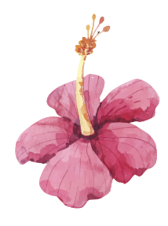
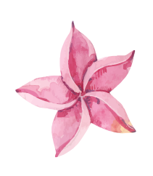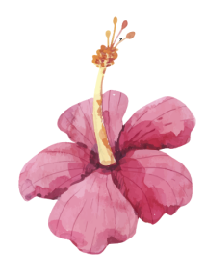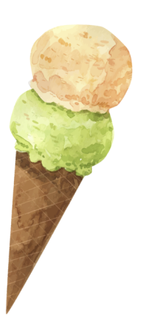
AGE:
BIRTHDAY:
WHAT MAKES ME HAPPY
MY HOBBIES
FAVORITE
MUSICIAN:
DESSERT:
SEASON:
MUSIC:
BOOK:
DESSERT:
DRINKS:
ACTOR:
HOLIDAY:
ANIMAL:
HOBBY:
MOVIE:
RESTAURANT:
FOOD:
NICKNAME:
NAME:
About me

