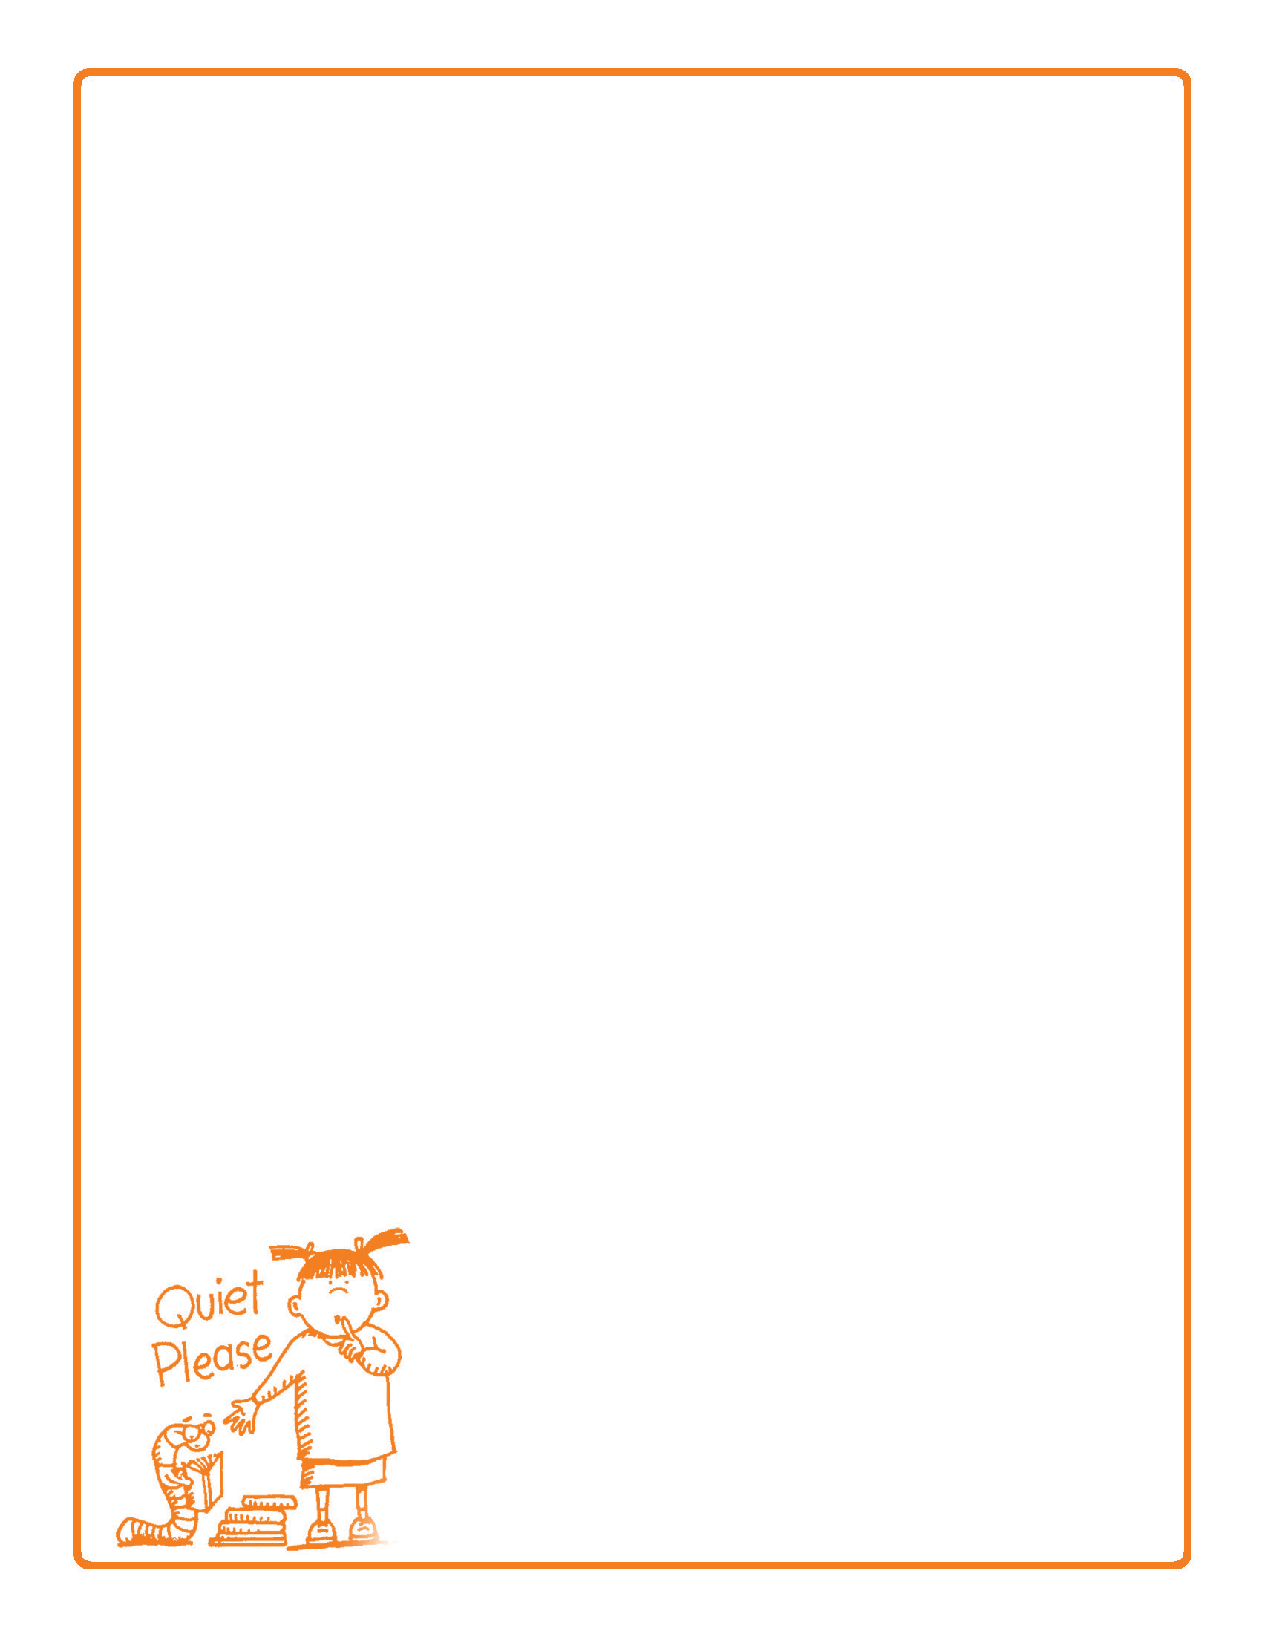
Behavior Contract
Date:
I promise to work on these behavior expectations:
Choose 3 of the following or create your own.
I will avoid whining
I will go to bed when asked
I will not interrupt
I will complete my homework on time
I will not hit
I will use good manners
I will respect the property and privacy of others
I will avoid places and objects that are unsafe or dangerous
I will be sensitive to the feelings of others
I will present a positive attitude instead of being negative, pessimistic
or rude
I will not tattle
I will get ready for school on time
I will take responsibility for my actions and not blame others
I will pick up after myself
I will keep good hygiene
I will eat healthy foods
I will
I will do my chores
I will
I will
Reward for meeting these expectations:
Consequence for not meeting these expectations:
Child Signature: Date:
Parent Signature: Date:

