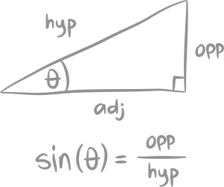
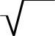

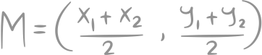
4
9
FRAYER MODEL FOR MATH
THINGS IT HAS TO HAVE/BE
EXAMPLES
THINGS IT MIGHT HAVE/BE
THINGS IT CAN'T HAVE/BE
- The numbers
- Square root
- Represented by two equal factors
- Positive
- Negative
- Decimal
- Fraction
16
25
- Negative
PERFECT SQUARE

