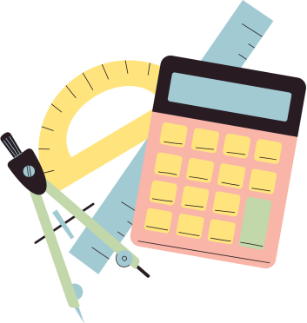
Definition
Facts / Characteristics
Non-examples
Examples
FRAYER MODEL FOR MATH

