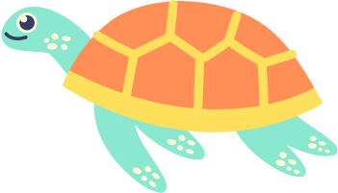
Definition
Examples
Characteristics
Non-examples
TURTLE
A reptilian animal with a hard shell on its back
  - Can pull its head and legs back inside its shell
  - Can live a long time
  - Is cold-blooded
  - Myrtle at the Aquarium
  - Snapping Turtle
  - Sea Turtle
  - Lizard
  - Snake
  - Alligator
  - Fish
FRAYER MODEL VOCABULARY

