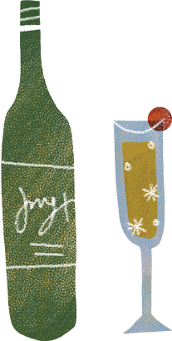
WINE
Definition
Sentence
Synonums
Picture
A drink made from fermented graphs and therefore counting as a serving of fruits. Improves the taste of many foods and the personalities of many friends.
drink, burgundy, booze, vino, claret
My parent love wines.
Frayer model vocabulary

