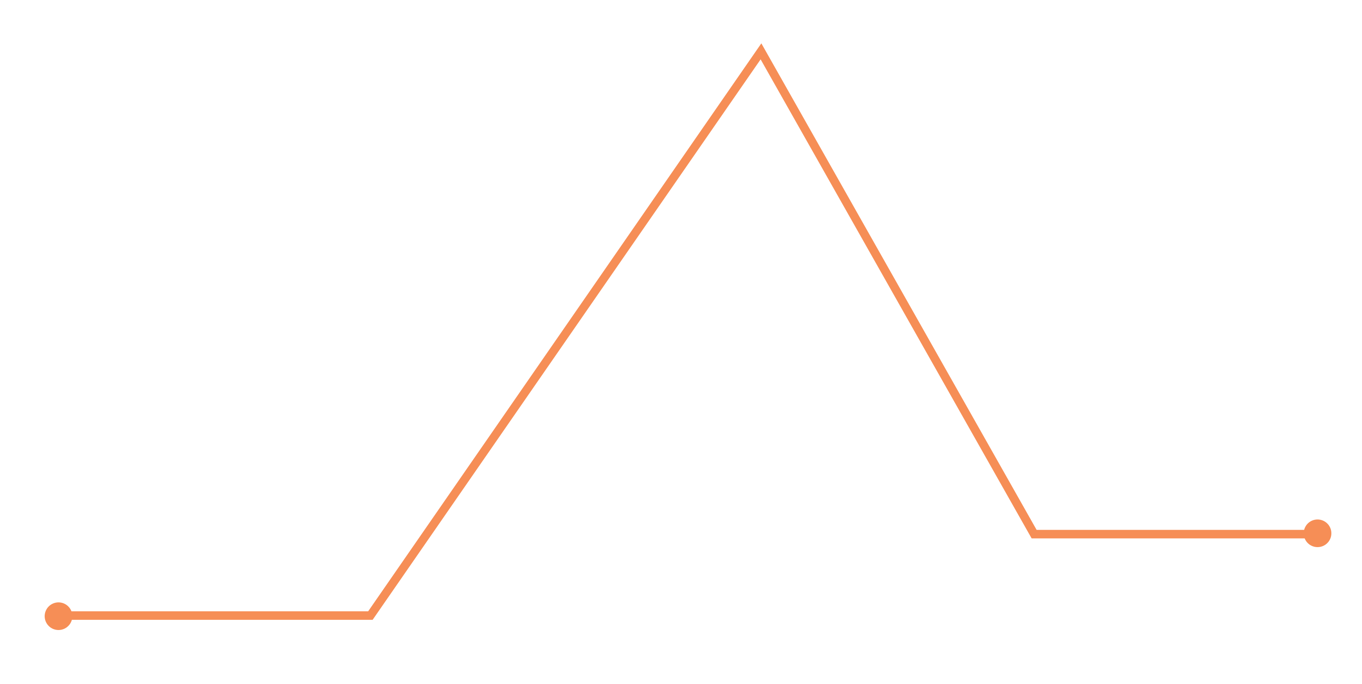
BOOK
PLOT DIAGRAM

RESOLUTION
FALLING ACTION
CLIMAX
RISING ACTION
CONFLICT
EXPOSITION
FALLING ACTION
RESOLUTION

EXPOSITION

CLIMAX
CONFLICT
RISING ACTION

