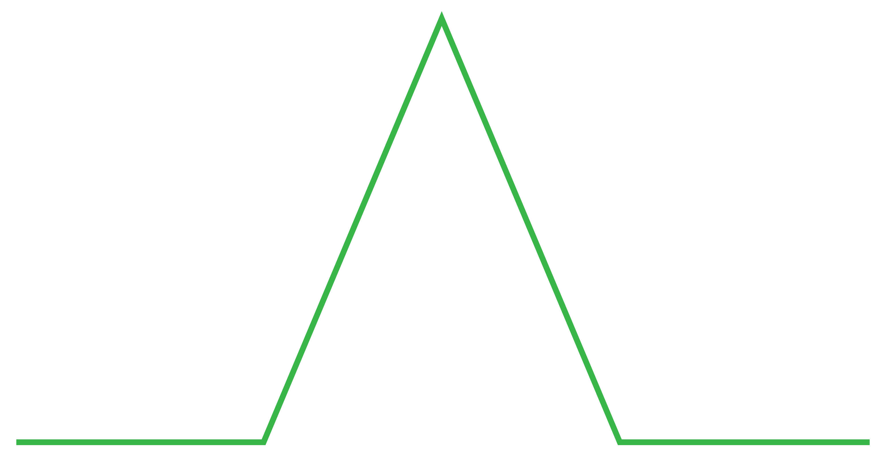
Linear
plot
DIAGRAM
FALLING ACTION
PROBLEM
BEGINNING
EXPOSITION
RESOLUTION

