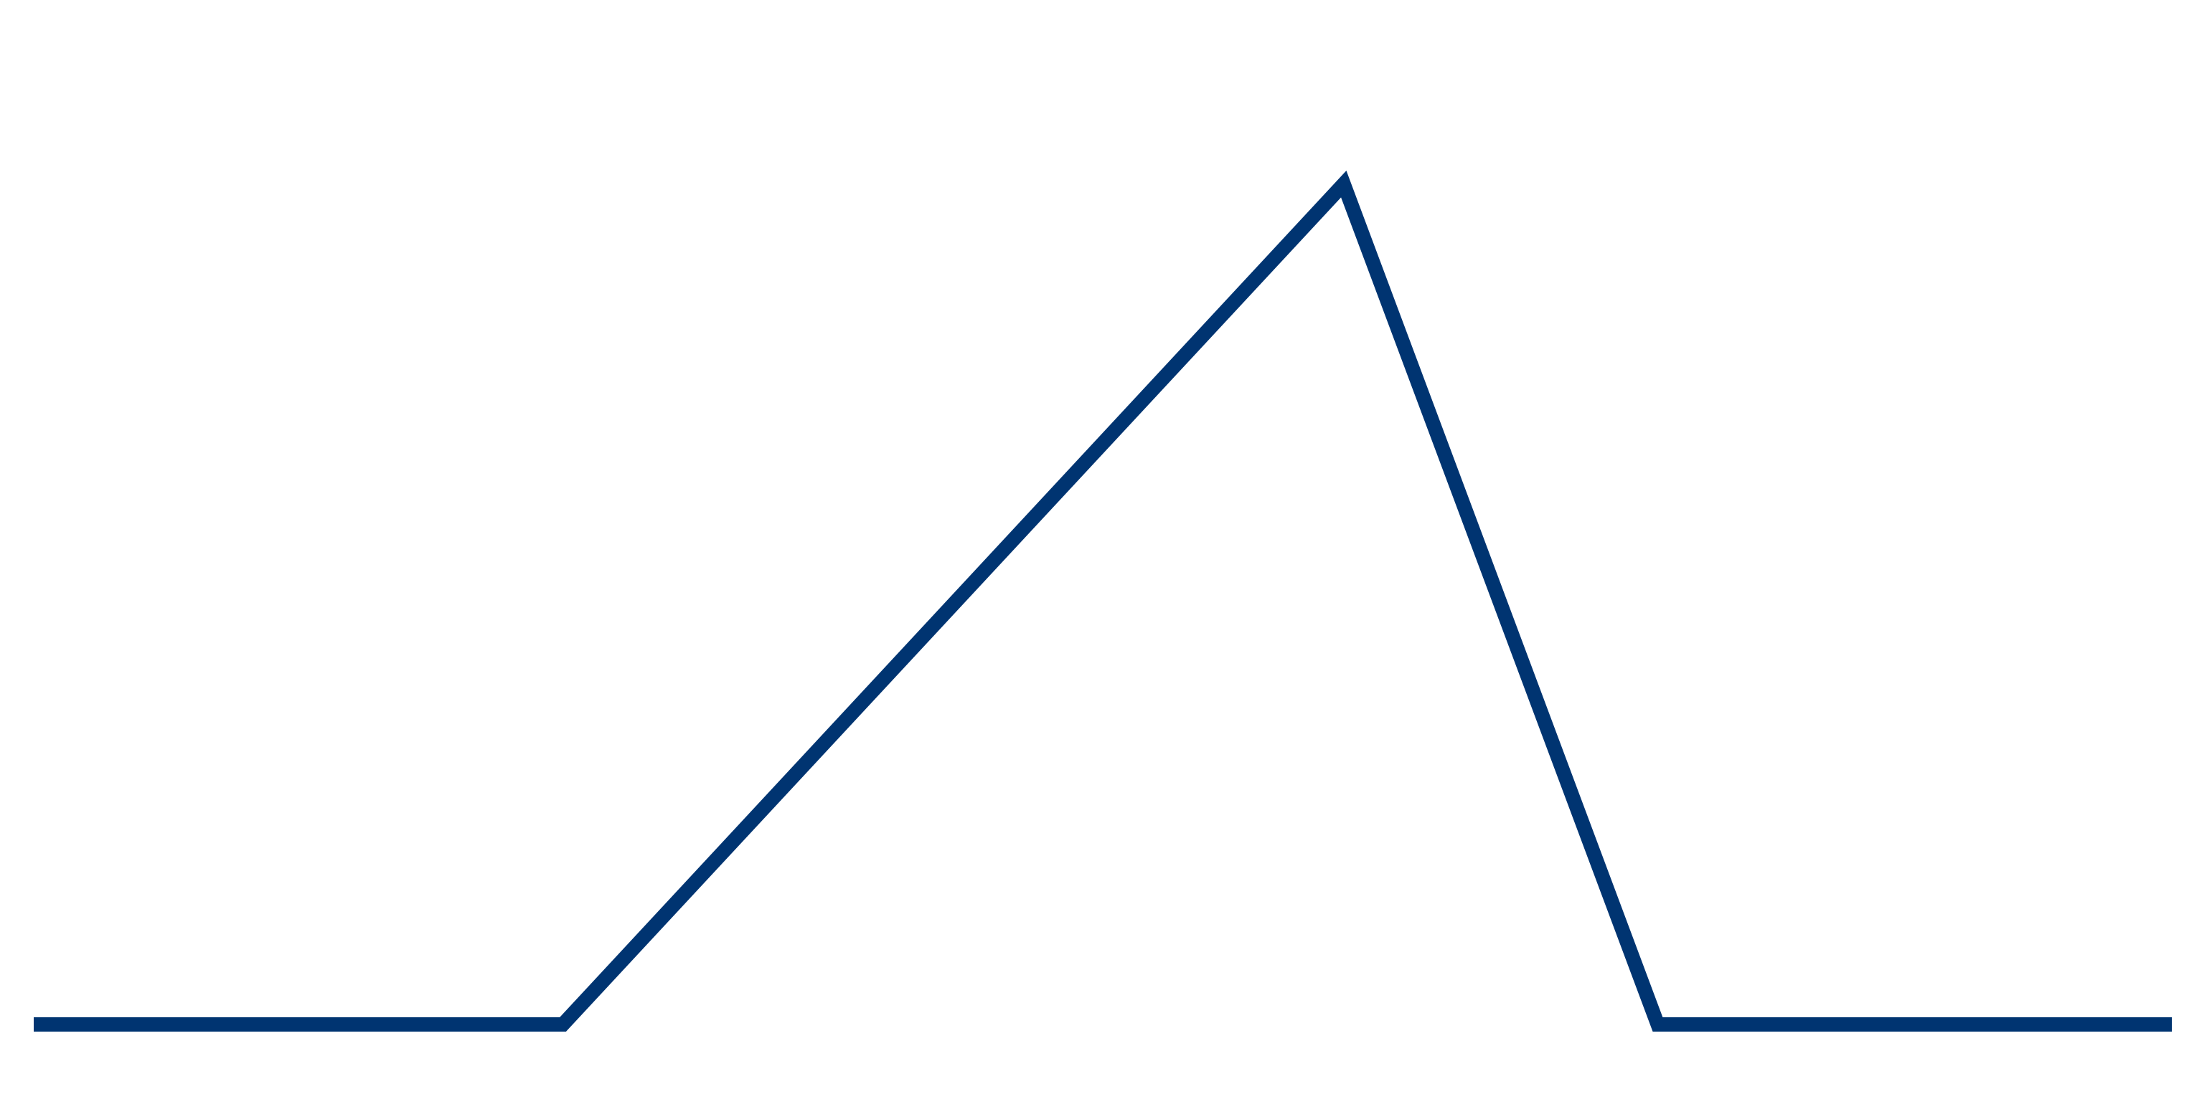
RESOLUTION
FALLING ACTION
RISING ACTION
CONFLICT
END
MIDDLE
BEGINNING
EXPOSITION
MOVIE PLOT DIAGRAM

