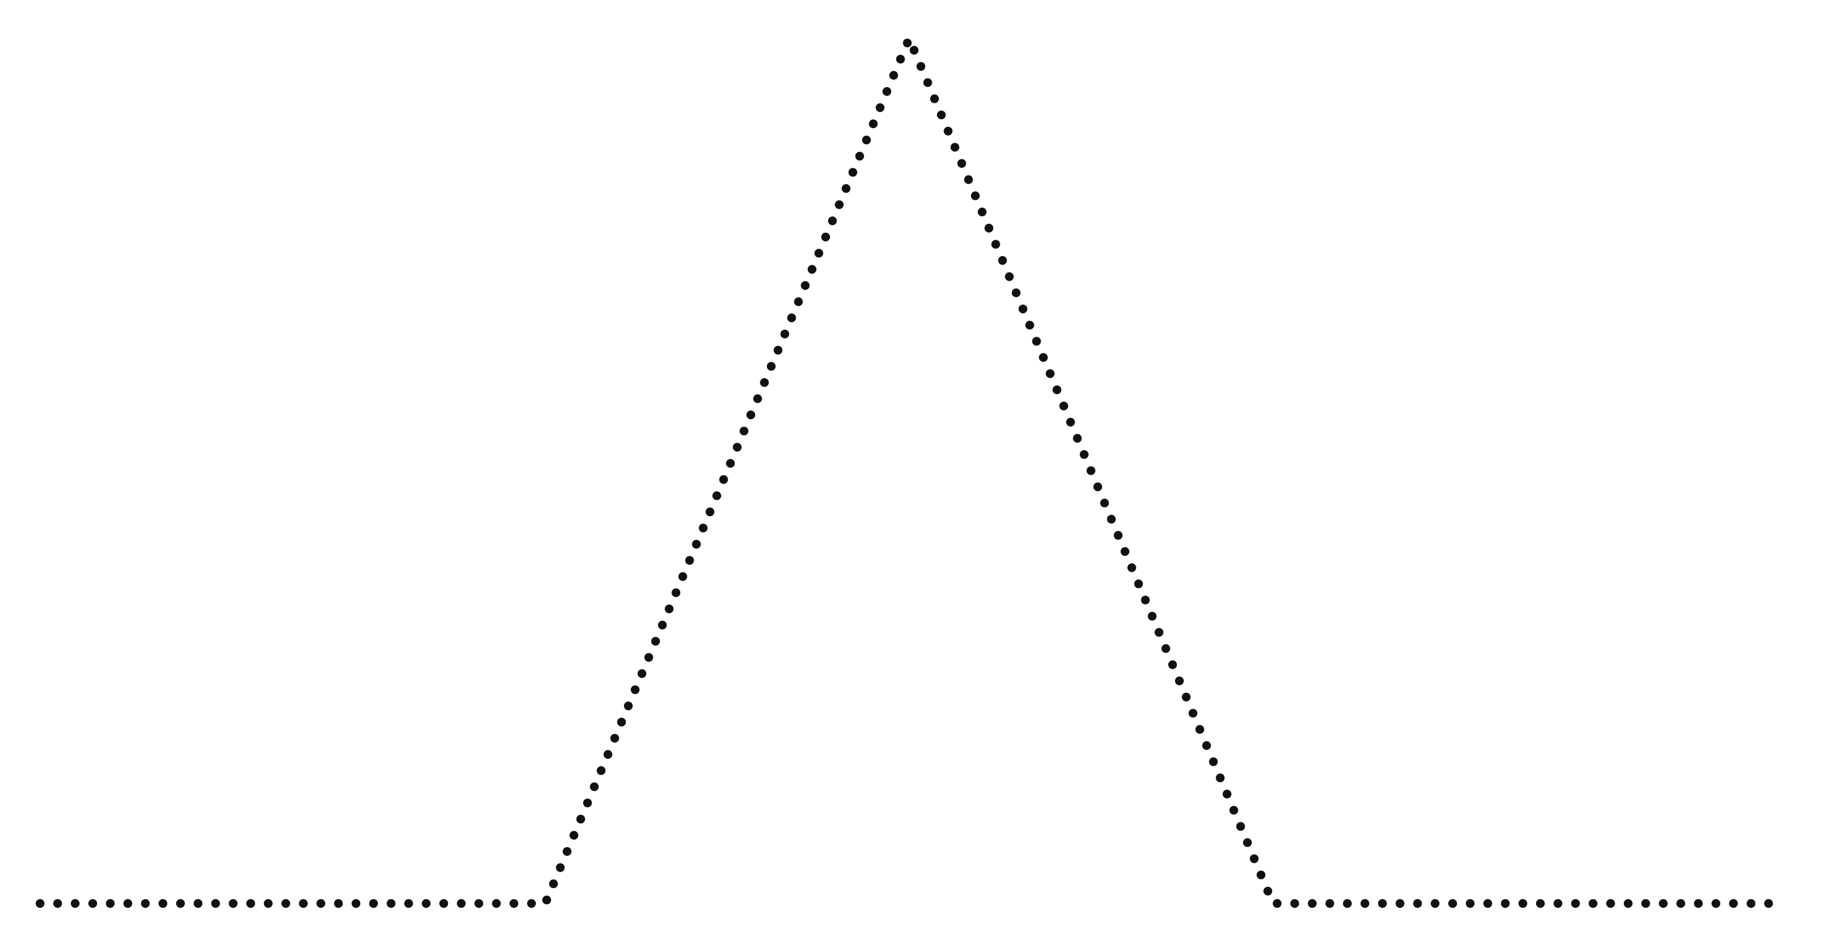
2
3
4
MOVIE PLOT DIAGRAM
5
1
RESOLUTION
FALLING ACTION
CLIMAX
RISING ACTION
EXPOSITION

