
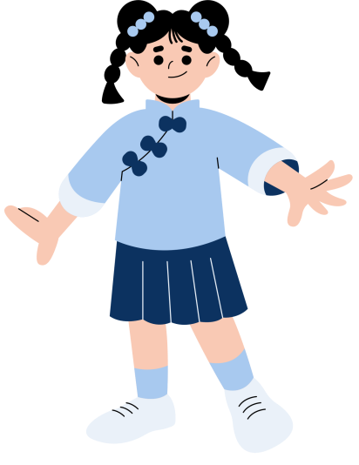
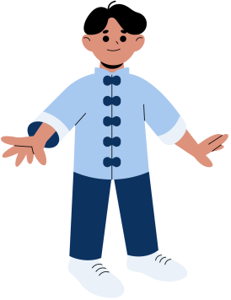
MONTH:
newsletter
ELEMENTARY
WHAT WE'RE LEARNING
PARENT CORNER
STUDENT ACHIEVEMENTS
UPCOMING EVENT

