


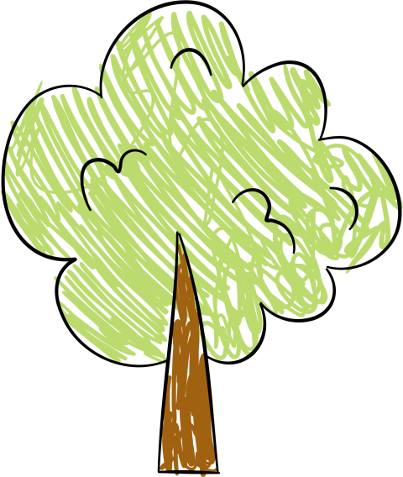

KINDERGARTEN NEWSLETTER
WHAT ARE WE LEARNING?
UPCOMING FIELD TRIPS
ACTIVITIES PARENTS CAN DO AT HOME
DATE :

