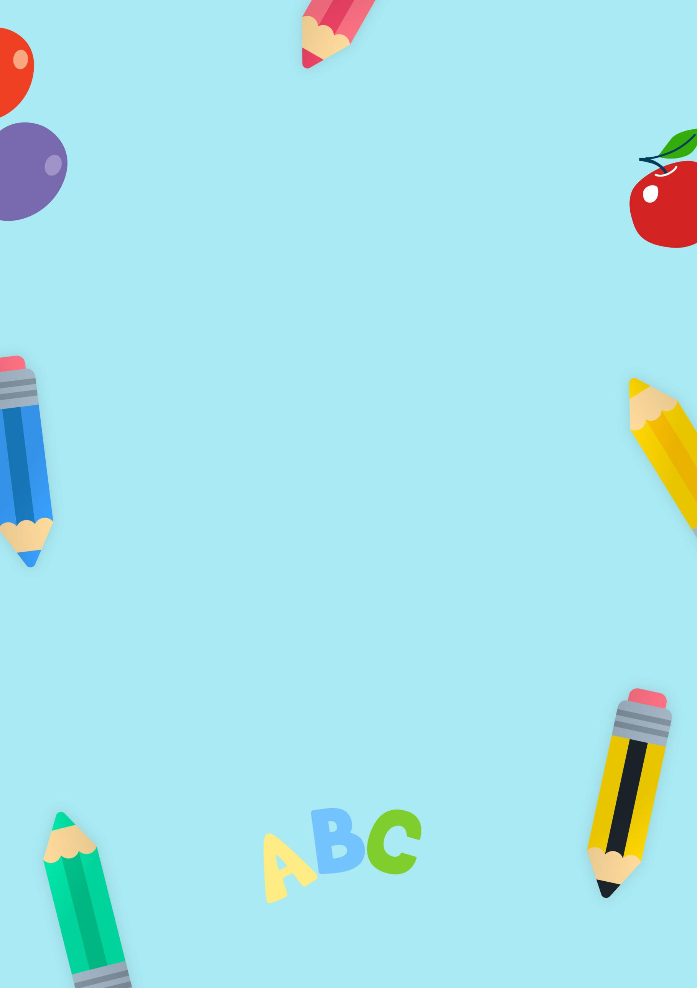
THIS WEEK
Teacher:
in our class
Reminders
Important Dates
What are we learning?
Date:

