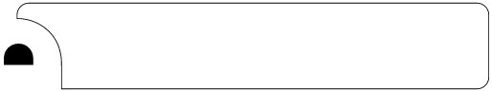
Sample Rubric Template

You may want to use the sample rubric below or create your own to complete the Getting Started Activity in this course. You can use this rubric to help identify the factors that you will use to measure progress on meeting your learning objective and the specific criteria you’ll use to assess the extent to which that learning objective has been met.

 | Excellent  4 | Good  3 | Needs  Improvement  2 | Unacceptable  1 | No  Judgment Possible
© 2006 Teachscape

