Name
Date
Lesson
Write Each Spelling Word Three Times
1.
2.
3.
4.
5.
6.
7.
8.
9.
10.

11.

12.

13.

14.

15.

Name
Date
Lesson
Write Your Words in ABC Order
1.
2.
3.
4.
5.
6.
7.
8.
9.
10.
11.
12.
13.
14.
15.



Name
Date
Lesson
Write Five Sentences Using Your Spelling Words
Use at least one spelling word per sentence;
your spelling words.
1.
2.
3.
4.
5.
Write the words you did not use:
Graphics by: graphicsfactory.com © whysospecial.com
box


Name
Date
Lesson
Spelling Pretest
1.
2.
3.
4.
5.
6.
7.
8.
9.
10.
11.
12.
13.
14.
My Spelling Pretest Score:
15.
Graphics by: graphicsfactory.com © whysospecial.com
15

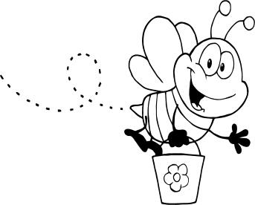
Name
Date
Lesson
Spelling Test
1.
2.
3.
4.
5.
6.
7.
8.
9.
10.
11.
12.
13.
14.
My Spelling Test Score:
15.
15
Graphics by: graphicsfactory.com © whysospecial.com

