
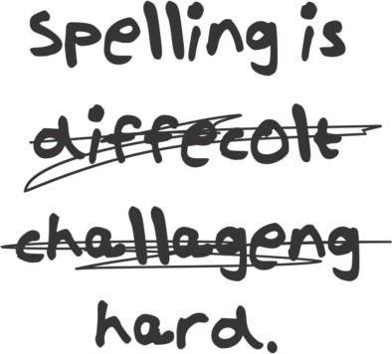

Simplifying Spelling
Richard Scott
Please see page 39 for a list of resources that have informed this booklet.
Aug 2018. Kindly contributed by Richard Scott, Warwickshire Adult & Community Learning. Search for Richard on www.skillsworkshop.org
E1-L2 Functional English (writing). For related resources and curriculum links visit the download page for this resource at skillworkshop.
Page 1 of 43

This bullet point means there is a tip that you can use.
? This bullet point means there is a task for you to do.


Simplifying Spelling
Name Date
Contents
Aug 2018. Kindly contributed by Richard Scott, Warwickshire Adult & Community Learning. Search for Richard on www.skillsworkshop.org
E1-L2 Functional English (writing). For related resources and curriculum links visit the download page for this resource at skillworkshop.
Page 2 of 43
Page
Topic
4
Common misspellings (with corresponding Functional English levels)
5
My spelling list (with general spelling tips)
6
What is spelling and why it is important?
7
What can cause misspelling?
8
How do you check your spelling?
9
Using a spell-checker
10
How to improve your spelling:
11
Break words up – compound words
12
Break words up – syllables
13
Break words up – words in words
14
Break words up – affixes
15
Break words up – affixes - prefixes
16
Break words up – affixes - suffixes
17-19
Using different senses – visual memory – word shapes
20
Using different senses – other visual memory aids
21
Using different senses – auditory memory – say it oddly
22
Using sentences (mnemonics) – silent letters, acrostics
23
Using sentences (mnemonics) – words in words, visual memory

Simplifying Spelling
Name Date
Contents (continued)
Aug 2018. Kindly contributed by Richard Scott, Warwickshire Adult & Community Learning. Search for Richard on www.skillsworkshop.org
E1-L2 Functional English (writing). For related resources and curriculum links visit the download page for this resource at skillworkshop.
Page 3 of 43
Page
Topic
24
Additional tips and tricks including: word origins, vowels, LSCWC
25
Look-Say-Cover-Write-Check template
26
Spelling rules: plurals
27
plurals (continued), adding -es to verbs
28
double consonants and silent/magic ‘e’
29
suffixes
30
prefixes, homonyms
31
letter sounds, ‘i’ before ‘e’,
32
verbs, abbreviations, capital letters
33-34
Spelling Practice
35
Notes / Questions
36
Answers Syllables
37
Compound words. words in words
38
Prefixes, suffixes, sentences (words in words)
39
Resources that have informed this booklet, and further reading
40-43
Functional skills English mapping

Simplifying Spelling
Name Date
*Levels E1, E2 & E3 link to the Entry Level spelling expectations published in the appendix of the 2018
Functional English Content which comes into effect in September 2019.
DfE (Feb 2018), Subject content functional skills: mathematics https://www.gov.uk/government/publications/functional-skills-subject-content-mathematics Also see pages 41-43 of this resource.
Aug 2018. Kindly contributed by Richard Scott, Warwickshire Adult & Community Learning. Search for Richard on www.skillsworkshop.org
E1-L2 Functional English (writing). For related resources and curriculum links visit the download page for this resource at skillworkshop.
Page 4 of 43
1
acceptable
It is not acceptable to smoke in the toilets.
E3
2
remember
Please remember to bring your ID.
E2
3
accommodation
The accommodation was 5-star.
L1-2
4
occasion
You will never have an occasion to wear it again.
E3
5
achieve
To achieve you must study at home.
E3
6
relevant
I will learn spellings that are relevant to me.
L1-2
7
argument
They had an argument about paying the bill.
E2
8
beautiful
It is a beautiful day.
E2
9
separate
You need to separate the laundry.
E3
10
because
I did it because I wanted to.
E1
11
knowledge
Knowledge is power.
E2
12
believe
I believe in you.
E2
13
calendar
Can you check your calendar?
E2
14
definite
Give me a definite answer.
E3
15
business
The business went bust.
E3
16
difficult
I can be difficult.
E2
17
embarrass
I didn’t mean to embarrass you.
L1-2
18
Wednesday
Today is Wednesday.
E1
19
equipment
Can you get the equipment?
E2
20
friend
Add me as a friend on Facebook.
E2
21
communication
Communication is key to a happy relationship.
E3
22
necessary
It is necessary to practise at home.
L1-2
23
queue
There was a big queue for the cinema.
L1-2
24
a lot
There were a lot of ants in the nest.
E1
25
receipt
Please can I have a receipt?
L1-2
26
restaurant
The food in the restaurant was lovely.
L1-2
27
said
They said it would be easy.
E1
28
neighbour
My neighbour is a pain.
L1-2
29
successful
To be successful you need to work hard.
E3-L1
30
write
Please write down your address.
E1
Common misspellings *Level


Simplifying Spelling
Name Date
My spelling list
Keep a personal dictionary or a list of spellings that are important and useful to
you. Use the space below (and maybe store the list on your phone) and keep revisiting these spellings. Use extra paper if you run out of space.
Only learn a few words at a time. Do not overcrowd your brain.
Concentrate on the part you have got wrong. You already know how to spell the rest of the word.
Use the tips in this booklet to help.
Aug 2018. Kindly contributed by Richard Scott, Warwickshire Adult & Community Learning. Search for Richard on www.skillsworkshop.org
E1-L2 Functional English (writing). For related resources and curriculum links visit the download page for this resource at skillworkshop.
Page 5 of 43

Spelling
Sentence and/or tip.
1

2

3

4

5

6

7

8

9

10

11

12

13

14

15


Simplifying Spelling
Name Date
What is spelling and why is it important?
•
Your aim is to make spelling automatic so there is no hesitation when writing.
To save time in an exam underline or highlight words you
are not sure of and come back to them later.
•
You need to take risks as a writer and a speller. Have a go at spelling
unfamiliar words and you might surprise yourself.
If you really cannot think of the spelling replace it with a
word that has a similar meaning (synonym). See the cover of this book for an example.
•
You must be able to check your work for mistakes. Make sure you see
exactly what is on the page rather than what you think is written.
Reading the written piece backwards (word by word - not
reading the words backwards) can help.
•
English has evolved over time and has borrowed many words from different
languages. This complicates English spelling. This 10-minute video provides a fun summary of some of the main historical influences:
www.youtube.com/watch?v=H3r9bOkYW9s History of English (The Open University)
•
Poor spelling irritates and distracts the reader. It disrupts the flow of his or
her reading.
•
Be positive about your spelling. You can spell!
You just need a method to help you.
Aug 2018. Kindly contributed by Richard Scott, Warwickshire Adult & Community Learning. Search for Richard on www.skillsworkshop.org
E1-L2 Functional English (writing). For related resources and curriculum links visit the download page for this resource at skillworkshop.
Page 6 of 43

Simplifying Spelling
Name Date
What can cause misspelling?
•
Lack of visual memory/recognition of a word’s shape.
•
Poor handwriting, poor letter shapes and the lack of a flowing hand.
Using clear joined-up writing helps you see and feel the word’s shape compared to print writing.
•
The English spelling system is complex – too many exceptions to the rule.
•
Sound-symbol relationship of English – 44 sounds represented by 26
letters (20 of these sounds use the vowels, including the letter ‘y’).
•
How you and others pronounce the word.
•
You’ve used the incorrect spelling for so long and
corrected.
have
never
been
•
You over-rely on IT or other resources to spell for you.
Aug 2018. Kindly contributed by Richard Scott, Warwickshire Adult & Community Learning. Search for Richard on www.skillsworkshop.org
E1-L2 Functional English (writing). For related resources and curriculum links visit the download page for this resource at skillworkshop.
Page 7 of 43

Simplifying Spelling
Name Date
How can you check your spelling?
Using other resources to help with your spelling is helpful but be careful not to
over-rely on them. These resources may not be around when you need them, e.g. in an exam.
•
Predictive text on a mobile phone
- Does not always get you the right spelling
Speech-to-text recognition software (computer, phone, etc)
- Does not always get you the right spelling because of accent, homophones, etc.
Books
•
•
o
Dictionaries (definition) and Thesauri/Thesauruses (synonyms –
similar meaning words) Online
Paper
Electronic
o o o
o
Aurally
Coded
English
(ACE)
Spelling
Dictionary (ordered
phonetically not alphabetically)
Etymology (origins on words)
Mobile apps
www.urbandictionary.com (for everyday (slang) words that you won’t find in the dictionary and is created by the general public i.e. selfie)
o
o o
•
Word processor (i.e. Microsoft Word)
o o
o
Red line – spelling
Green line – grammar
Blue line – homonyms, ‘Are you sure you wanted to use that word?’ (Microsoft Office 2010 onwards)
- See next page
•
Ask someone else
o Assuming they know the correct spelling – they may not
Aug 2018. Kindly contributed by Richard Scott, Warwickshire Adult & Community Learning. Search for Richard on www.skillsworkshop.org
E1-L2 Functional English (writing). For related resources and curriculum links visit the download page for this resource at skillworkshop.
Page 8 of 43

Simplifying Spelling
Name Date
Using a spell-checker
Using a spell-checker can be useful but be careful. The following poem on the
left was run through Microsoft’s spell-checker and it only highlighted 6 mistakes.
Aug 2018. Kindly contributed by Richard Scott, Warwickshire Adult & Community Learning. Search for Richard on www.skillsworkshop.org
E1-L2 Functional English (writing). For related resources and curriculum links visit the download page for this resource at skillworkshop.
Page 9 of 43
Original
Translation

Ode to Spell Checker
Eye halve a spelling checker It came with my pea sea
It plainly marks four my revue Miss steaks eye kin knot sea.

Eye strike a key and type a word And weight four it two say Weather eye am wrong oar write It shows me strait a weigh.

As soon as a mist ache is maid It nose bee fore two long
And eye can put the error rite Its rare lea ever wrong.

Eye have run this poem threw it I am shore your pleased two no Its letter perfect awl the weigh
My checker tolled me sew.

Ode to Spell Checker I have a spell checker It came with my PC
It plainly marks for my review Mistakes I cannot see.

I strike a key and type a word And wait for it to say Whether I am wrong or right It shows me straight away.

As soon as a mistake is made It knows before too long
And I can put the error right It’s rarely ever wrong.

I have run this poem through it I am sure you’re pleased to know
It’s letter perfect all the way
My checker told me so.
red = spelling query (none) green = grammar query blue = homonyms query

Simplifying Spelling
Name Date
How to improve your spelling
Regular reading may improve your spelling and reading because you are looking
at words and storing them away in your visual memory. Your visual memory is
like a filing cabinet full of pictures, or shapes, of words. Good readers read by just looking very quickly at a word and recognising its shape.
Even more useful is to do what weak spellers don’t like – writing! When you read,
the correct spellings are on the page in front of you. When you write, you have to find the spellings from your memory’s filing system, which may be in a bit of a muddle. The more often you task your brain with finding words you want, the
more the words will stick.
Brains are naturally quite lazy but you can improve your filing system if you make
your brain work harder.
It is very important to practise your spellings every day. The practice will only
take one or two minutes so you could, for example, do it during a commercial break when watching your favourite TV programme.
People who practice every day become better spellers. Those who try to get
away with it with once or twice a week, unfortunately, are not likely to remember the spellings forever.
Even if you think you have got the spelling after the second or third time, you
should continue practising the spelling for the rest of the week to commit the spelling to memory.
Pages 11-25 describe a range of spelling strategies and ideas.
Pages 26-32 list some common spelling rules.
Find the ones that work for you and your spellings.
Aug 2018. Kindly contributed by Richard Scott, Warwickshire Adult & Community Learning. Search for Richard on www.skillsworkshop.org
E1-L2 Functional English (writing). For related resources and curriculum links visit the download page for this resource at skillworkshop.
Page 10 of 43

Simplifying Spelling
Name Date
There are many ways you can break up words:
•
•
•
•
•
Small words
Syllables
Words within words
Prefixes and Suffixes
Say it oddly
Some people are good at remembering sounds
in
a word. Others are better at
knowing what a word looks like. When you split up a word aim for groups of
roughly three letters and avoid leaving one letter on its own.
A compound word is made when two words are joined together to make a new
word. For example, joining ‘tooth’ and ‘paste’ gives you the new word ‘toothpaste’.
snow
tooth break news hose
hand
paste
paper pipe fast bag
man
toothpaste
Aug 2018. Kindly contributed by Richard Scott, Warwickshire Adult & Community Learning. Search for Richard on www.skillsworkshop.org
E1-L2 Functional English (writing). For related resources and curriculum links visit the download page for this resource at skillworkshop.
Page 11 of 43

? Can you think of some more compound words? Write them below.
? Match the following words together to create a new longer word. Draw lines between them and then write the new compound word on the dotted line.
Compound Words
Break Words Up


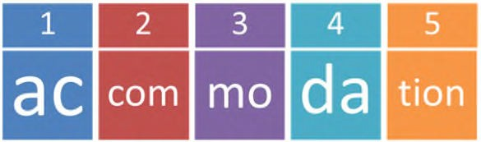

Simplifying Spelling
Name Date
Finding syllables in words is one of the best ways to break up words. A syllable
is one letter or a group of letters, which forms part of a word – sometimes it can be the whole word itself.
There are many ways to describe a syllable. A syllable is:
1. A beat in a word. Think about beating time to a word with a drum. The number
of beats in the word should be the same as the number of syllables.
2. A push of breath. Each syllable uses its own bit of breath as you breathe out.
3. A chunk of a word with one vowel sound in it.
4. The sound you make when you speak and you jaw drops down. Rest you chin
on the back of your hand and feel each syllable when you say a word.
All words can be broken into syllables. A word can contain one syllable or several.
Example:
The word ‘accommodation’ splits into 5 syllables.
Aug 2018. Kindly contributed by Richard Scott, Warwickshire Adult & Community Learning. Search for Richard on www.skillsworkshop.org
E1-L2 Functional English (writing). For related resources and curriculum links visit the download page for this resource at skillworkshop.
Page 12 of 43
? Use the list on page 4 or your own spelling list. Split each word into syllables. Use the syllables to practise, and then test yourself.
It may help to write the word’s syllables down, cut them up and then stick them onto coloured paper with a small gap between each syllable.
If you struggle to work out syllables, this website may help:
http://www.howmanysyllables.com
Break Words Up
Syllables

Simplifying Spelling
Name Date
Most of us are confident about spelling and reading short words. You can use
these short words to help spell longer ones. Memory is a strange thing. You are more likely to remember something that is a bit odd, funny or rude.
Look at the word ‘library’. Can you see anything a bit odd, funny or rude inside
the word?
Can you see the bra
in library?
o
vegetable
o
many
o
shorter
o
words
o
inside
them
o
Aug 2018. Kindly contributed by Richard Scott, Warwickshire Adult & Community Learning. Search for Richard on www.skillsworkshop.org
E1-L2 Functional English (writing). For related resources and curriculum links visit the download page for this resource at skillworkshop.
Page 13 of 43
? How many small words can you find in the following words (without reordering the letters)?
Break Words Up
Words in Words

Simplifying Spelling
Name Date
Break Words Up
Affixes
Some words are made up of a main word (also called ‘base word’ or ‘root word’)
with groups of letters added to the beginning or the end of a word. These groups of letters are called ‘affixes’ (affix means to fix to).
The group of letters that are added to the beginning of a word is called a prefix
(from Latin circa 15th Century - ‘pre’ meaning before and ‘fix’ meaning fix)
Example:
Prefix
Base
New word
unhappy
un + happy
=
The group of letters that are added to the end of a word is called a suffix (from
Latin circa 15th Century ‘suf’ meaning on top of and ‘fix’ meaning fix)
Example:
Base
comfort +
Suffix
able
New word
comfortable
=
Sometimes there are many prefixes and suffixes in one word; for example,
‘antidisestablishmentarianism’. If you break it into smaller parts YOU CAN SPELL IT!
anti
Prefix
dis
Prefix
establish
Base
ment
Suffix
arian
Suffix
ism
Suffix
Now you have broken it up you have lots
of small
words to help you spell the
larger word. Some you may already be able to spell.
Aug 2018. Kindly contributed by Richard Scott, Warwickshire Adult & Community Learning. Search for Richard on www.skillsworkshop.org
E1-L2 Functional English (writing). For related resources and curriculum links visit the download page for this resource at skillworkshop.
Page 14 of 43

Simplifying Spelling
Name Date
Base words to match with the prefix:
Aug 2018. Kindly contributed by Richard Scott, Warwickshire Adult & Community Learning. Search for Richard on www.skillsworkshop.org
E1-L2 Functional English (writing). For related resources and curriculum links visit the download page for this resource at skillworkshop.
Page 15 of 43

? Can you think of some more words with prefixes? Write them below.
mortem
frost
form
storey
agree
sleep
fair
paid
play

Prefix meaning
Prefix
Base
Total meaning

pre

post

over

uni

multi

re

de

un

dis

? Match each prefix with a base word. (There may be more than one combination). Then work out the meaning of the prefix.
Break Words Up
Prefixes

Simplifying Spelling
Name Date
Base words to match with the prefix:
Aug 2018. Kindly contributed by Richard Scott, Warwickshire Adult & Community Learning. Search for Richard on www.skillsworkshop.org
E1-L2 Functional English (writing). For related resources and curriculum links visit the download page for this resource at skillworkshop.
Page 16 of 43

? Can you think of some more words with suffixes? Write them below.
friend
arrange
accept
table
walk
reply
box
use
hope

Base
Suffix
Suffix meaning
Total meaning

ed

ing

s

es

able

ful

ment

less

ly

? Can you match each suffix with a base word? (N.B. There may be more than one combination). Then work out the meaning of the suffix.
Break Words Up
Suffixes



Simplifying Spelling
Name Date
The more senses you use, the more likely you are to remember a word. In
addition to sight and sound, you can also use touch and movement. For example, using magnetic letters on a fridge or writing on sandpaper.
•
•
•
•
Visual memory – what you remember by using your eyes
Auditory memory – what you remember by using your ears Motor memory – what you remember by using movement Tactile memory – what you remember by using touch
Most people practise their spelling by using pen and paper but you do not have
to. If you have a hobby you can use these to help with your spelling.
•
•
•
If you like painting, use paint and paint your spellings
If you like sewing, use needle and thread and sew your spellings If you like woodwork, use tools to carve your spellings into wood
We are good at remembering diagrams, pictures, shapes and colour (by using
our visual memory) but we are not so good when it comes to small, black marks on white paper (writing). Use your visual memory to help.
You may find the shape of the word, with some colour added, is
easier to remember than just the letters on their own. The word ‘daily’ makes a shape which is not the same as most other words:
Making a picture out of a difficult word can also help your
visual memory. For example, some people find it helps to draw a bus around the first three letters of ‘business’.
Aug 2018. Kindly contributed by Richard Scott, Warwickshire Adult & Community Learning. Search for Richard on www.skillsworkshop.org
E1-L2 Functional English (writing). For related resources and curriculum links visit the download page for this resource at skillworkshop.
Page 17 of 43
Visual Memory - Word Shape
Using different senses

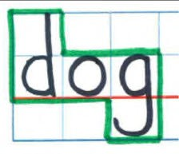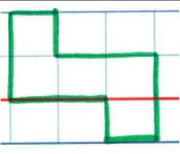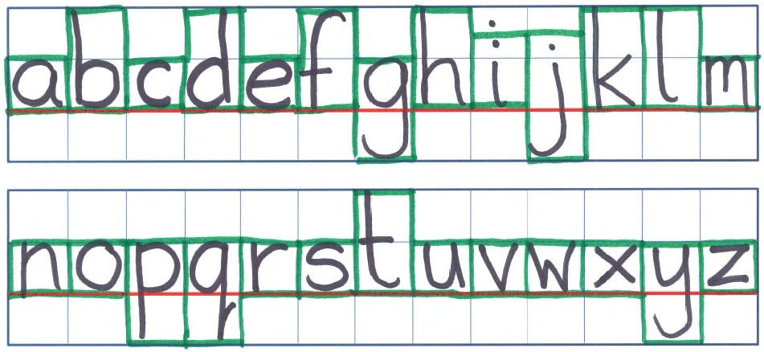
Simplifying Spelling
Name Date
Example:
Aug 2018. Kindly contributed by Richard Scott, Warwickshire Adult & Community Learning. Search for Richard on www.skillsworkshop.org
E1-L2 Functional English (writing). For related resources and curriculum links visit the download page for this resource at skillworkshop.
Page 18 of 43
The word ‘dog’ looks like this.
So the word shape is this.

? Choose a word that you find difficult to spell. Use the blank grid guide on the next page and write the word. The red line is the main line to write on. Ensure the letters fill the spaces as much as you can (see alphabet below for a guide
on how to write each letter to make use of the space).
Using different senses
Visual Memory - Word shape (continued)

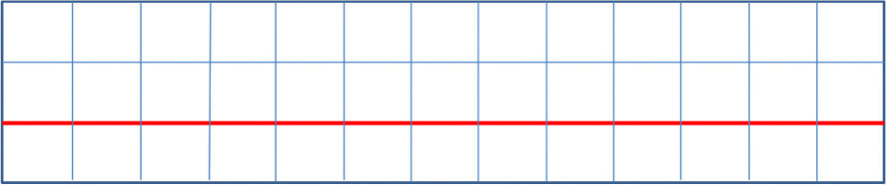
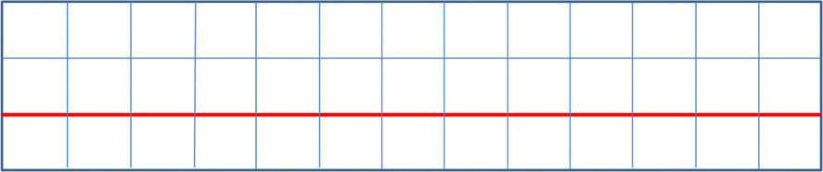
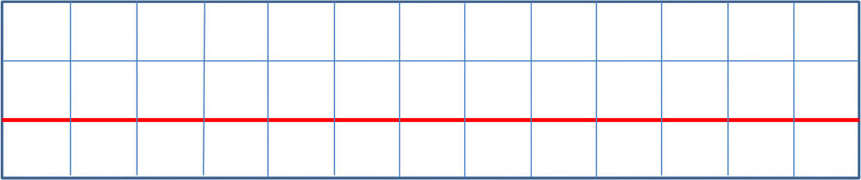
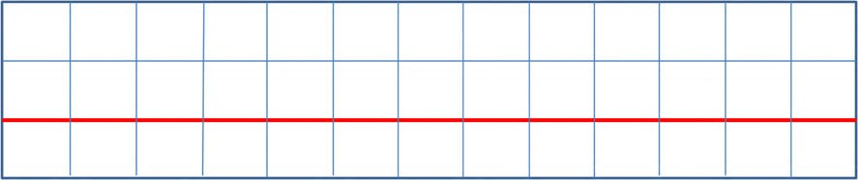
Simplifying Spelling
Name Date
Visual Memory - Word shape (continued)
? Write the spelling word below. Then draw around it with a coloured pen.
? Now draw just the shape in this box, without the letters.
Aug 2018. Kindly contributed by Richard Scott, Warwickshire Adult & Community Learning. Search for Richard on www.skillsworkshop.org
E1-L2 Functional English (writing). For related resources and curriculum links visit the download page for this resource at skillworkshop.
Page 19 of 43

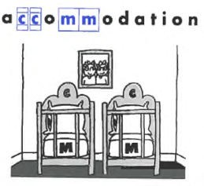

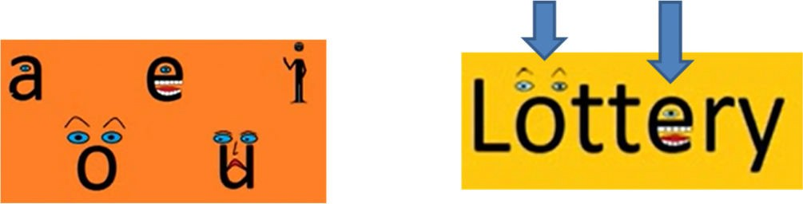
Simplifying Spelling
Name Date
Sometimes just highlighting
of a word may be all that is
.
You might remember that the word ‘accommodation’ has two ‘c’s and two
‘m’s if you picture accommodation with two cots and two mattresses:
You might remember that the word ‘necessary’ if you picture the ‘c’
nose and the ‘s’s as two hissing snakes:
as
a
Give the letters human characteristics. ‘Surprised’ and ‘happy’ they won.
Aug 2018. Kindly contributed by Richard Scott, Warwickshire Adult & Community Learning. Search for Richard on www.skillsworkshop.org
E1-L2 Functional English (writing). For related resources and curriculum links visit the download page for this resource at skillworkshop.
Page 20 of 43
need
ed
parts

differ
ent

Using different senses
Other Visual Memory Aids

Simplifying Spelling
Name Date
Many words are said the way they are written but there are plenty that
are not. Try pronouncing the word in a different way to help with the spelling.
For example:
When we say the word ‘Wednesday’ we do not pronounce the ‘d’ so when you
are spelling ‘Wednesday’ break the word up and say the ‘d’
Aug 2018. Kindly contributed by Richard Scott, Warwickshire Adult & Community Learning. Search for Richard on www.skillsworkshop.org
E1-L2 Functional English (writing). For related resources and curriculum links visit the download page for this resource at skillworkshop.
Page 21 of 43
? Choose a difficult word that is not said how it is written.
Show below how you can break the word up and/or say it oddly to help you with the spelling.
Wed
nes
day
as in to marry

Using different senses
Auditory memory – say it oddly

Simplifying Spelling
Name Date
For spellings with silent letters, there are a couple of tricks you can use:
Simply remember it has a silent letter
Say it oddly
Create a sentence with words that share the same letter.
- The writer wrote about wrong wrinkles.
- The government govern the country.
- The knight knew the knack of knitting knickers
- The sign signals what to do.
Auditory Memory - Acrostics
In an acrostic the first letter of each word spells out a word or message.
‘small animals in danger’ spells the word ‘said’: small
animals
in danger
‘that horrible orange umbrella gave harry trouble’ spells the word ‘thought’
Aug 2018. Kindly contributed by Richard Scott, Warwickshire Adult & Community Learning. Search for Richard on www.skillsworkshop.org
E1-L2 Functional English (writing). For related resources and curriculum links visit the download page for this resource at skillworkshop.
Page 22 of 43
? Create an acrostic for a word you find difficult to spell. This can take a bit of work but is worth the effort. There are many sources on the internet that can
provide ideas to get you started (search ‘mnemonic generator’).
? Find a word where the silent letter causes you difficulty. Search for words that share the same letter and create sentences like those above.
Using sentences (mnemonics)
Auditory Memory - Silent Letters

Simplifying Spelling
Name Date
Find a smaller word in the spelling word and then create a memorable sentence.
Example:
o
Please can I have a piece of pie?
o o o o
o
If you lie to me I won’t believe you.
Add an address to your letter. The secretary will keep his secret.
Since I must rely on you, I am, sincerely yours.
You might have to spit when you are in hospital.
Sentences and visual memory
You can make sentences that help you picture something in your mind’s eye
or that indicate the difficult parts of word.
- It is necessary to have 1 collar and 2 sleeves on a shirt.
- The CID investigates incidents and accidents.
- If you are embarrassed you will have 2 red cheeks and 2 scarlet ears.
- William K. Williams is an awkward boy.
- Mathematics is easy.
Aug 2018. Kindly contributed by Richard Scott, Warwickshire Adult & Community Learning. Search for Richard on www.skillsworkshop.org
E1-L2 Functional English (writing). For related resources and curriculum links visit the download page for this resource at skillworkshop.
Page 23 of 43
? Find the smaller words in the word that is bold and underlined. Then find that word again in the sentence. Highlight or circle it.
Using sentences (mnemonics)
Word within words

Simplifying Spelling
Name Date
Additional Tips and Tricks
Knowing the origin of a word can help with the spelling as it will remind you
why the word does not follow English spelling rules. For this you will need an etymology dictionary which can be found in book stores or on the internet.
Focus on the vowels in the word; i.e. sentence (all ‘e’s), they (‘e’ not ‘a’,
although sounds like an ‘a’).
Try spelling and writing the word with your eyes closed so that you get a
‘feel’ of the spelling. Do this using sandpaper or other rough paper to give you a greater input/feel for the word (useful for people with dyspraxia too).
Look-say-cover-write-check
Use the template on the next page or copy it onto another piece of paper. Write the correct spelling in the 1st row.
Look at it.
Say it out loud and/or use a trick that helps you remember the spelling. Cover the correct spelling so you cannot see it.
Imagine the spelling on the paper in front of you or in your mind’s eye.
Wait at least 3 seconds before you try to write it (the longer you leave between looking and writing will increase the chance of the spelling staying in your long-term memory).
Write your spelling on the next blank row.
Double check what you have written and make changes if you need to.
1.
2.
3.
4.
5.
6.
7.
8.
9.
- Check what you have written with the correct spelling in the 1st row.
- Repeat steps 3-10 in the 3rd row and then again in the 4th row.
- Read your work backwards to check for spelling. Reading forward checks for
sense and you may miss spelling errors as you know what the writing is supposed to say.
Aug 2018. Kindly contributed by Richard Scott, Warwickshire Adult & Community Learning. Search for Richard on www.skillsworkshop.org
E1-L2 Functional English (writing). For related resources and curriculum links visit the download page for this resource at skillworkshop.
Page 24 of 43

Simplifying Spelling
Name Date
Look-Say-Cover-Write-Check Template
Aug 2018. Kindly contributed by Richard Scott, Warwickshire Adult & Community Learning. Search for Richard on www.skillsworkshop.org
E1-L2 Functional English (writing). For related resources and curriculum links visit the download page for this resource at skillworkshop.
Page 25 of 43

Correct spelling

Attempt 1

Attempt 2

Attempt 3


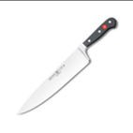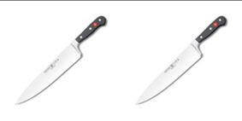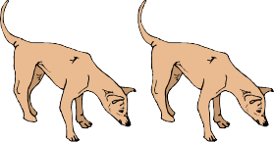
Simplifying Spelling
Name Date
Spelling Rules source: http://www.parkhurstss.eq.edu.au/index.php/about-parkhurst-state-school/curriculum/spelling/
Spelling Rules: Quick Guide
Plurals
Aug 2018. Kindly contributed by Richard Scott, Warwickshire Adult & Community Learning. Search for Richard on www.skillsworkshop.org
E1-L2 Functional English (writing). For related resources and curriculum links visit the download page for this resource at skillworkshop.
Page 26 of 43
When a word ends in ‘o’ and
6 comes after a consonant,
add ‘es’ to make the plural. one dingo two dingoes
When words end in ‘f’ or ‘fe’
5 change the ‘f’ or ‘fe’ to a ‘v’ before adding ‘es’.
one knife two knives
When words end in ‘ay’,
4 ‘ey’, ‘iy’, ‘oy’ and ‘uy’ add an ‘s’ to make the plural.
one turkey two turkeys
When the letter before a ‘y’
3 is a consonant, change the ‘y’
to an ‘i’ before adding an ‘es’. one poppy two poppies
Add ‘es’ to words ending
2 in ‘ch’, ‘sh’ ‘s’, ‘ss’, ‘x’ or ‘z’
to make the plural. one box two boxes

Most words add ‘s’
1
to make the plural.
one apple two apples

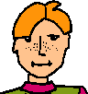
Simplifying Spelling
Name Date
Spelling Rules source: http://www.parkhurstss.eq.edu.au/index.php/about-parkhurst-state-school/curriculum/spelling/
Adding - es to verbs
Aug 2018. Kindly contributed by Richard Scott, Warwickshire Adult & Community Learning. Search for Richard on www.skillsworkshop.org
E1-L2 Functional English (writing). For related resources and curriculum links visit the download page for this resource at skillworkshop.
Page 27 of 43
When a verb word ends with a
The pirate buries
12 consonant followed by a ‘y’, change
his treasure.
the ‘y’ to an ‘i’ before adding ‘es’.
When a verb ends with a hissing
sound (‘sh’, ‘ch’, ‘ss’, ‘x’, ‘z’) add an ‘es’ Emma waltzes with
11
to make the 3rd person singular Les on Friday night.
present tense.
Some words, particularly those
10 from other languages, may have
exceptions when making plurals. one analysis two analyses

It may be confusing making
9 compound words into plural forms.
The significant word is made plural. My sisters-in-law are twins

Sometimes, a word stays the same in
8
both its singular and plural form.
one sheep two sheep
Sometimes, a word may
7 completely change its form
when a plural is made. one child two children
Spelling Rules: Quick Guide
Plurals (continued)

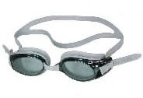
Simplifying Spelling
Name Date
Spelling Rules source: http://www.parkhurstss.eq.edu.au/index.php/about-parkhurst-state-school/curriculum/spelling/
Spelling Rules: Quick Guide
Double consonants and silent/magic ‘e’
Aug 2018. Kindly contributed by Richard Scott, Warwickshire Adult & Community Learning. Search for Richard on www.skillsworkshop.org
E1-L2 Functional English (writing). For related resources and curriculum links visit the download page for this resource at skillworkshop.
Page 28 of 43
For words ending in a silent
Kookaburras are
18 ‘e’, you must first drop very noisy birds.
the ‘e’ before adding a ‘y’.
When a word ends in a silent ‘e’,
Dave loves platform
17 drop the ‘e’ before adding an ‘ing’. diving on weekends.
The magic ‘e’ runs away!
Double the last letter of words Patrick enjoys
16 ending in a short vowel followed by a laying back on a
single consonant before adding a ‘y’. sunny day.
Double the last letter before adding
She’s a great
15 ‘er’ or ‘est’ to words that have a short swimmer.
vowel followed a single consonant.
Double the consonant before adding Grandad was sitting
14 ‘ing’ to words that have a short vowel in his chair all
followed by a consonant at the end. morning.
When a word ends with a short vowel She skipped for
13 followed by a consonant, double the last 20 minutes at
consonant before adding ‘ed’. the gym.


Simplifying Spelling
Name Date
Spelling Rules source: http://www.parkhurstss.eq.edu.au/index.php/about-parkhurst-state-school/curriculum/spelling/
Spelling Rules: Quick Guide
Suffixes
Aug 2018. Kindly contributed by Richard Scott, Warwickshire Adult & Community Learning. Search for Richard on www.skillsworkshop.org
E1-L2 Functional English (writing). For related resources and curriculum links visit the download page for this resource at skillworkshop.
Page 29 of 43
Just add a ‘y’ to words ending in
The last few days have
25 two consonants to form been quite windy here.
describing words.
When adding a vowel suffix
Vikings lived many,
24 to words ending in a silent ‘e’, many years ago.
drop the ‘e’ and add the suffix.
Before adding ‘er’ and ‘est’ to words
Dean is the skinniest
23 ending in a consonant, followed by a member at the gym.
‘y’, change the ‘y’ to an ‘i’.

The painting was very
22 The suffix ‘ful’ only has one ’l’. colourful.

When adding ‘ly’ to words
Amanda scored the
21 which end in ‘y’, change the ‘y’ goal quite daintily.
to an ‘i’ before adding the ‘ly’.
Often ‘ly’ is added to base words
The jelly turned out
20 to turn them into adverbs or perfectly.
adjectives.
For action words that end
Matthew enjoys lying on
19 in ‘ie’, change the ‘ie’ to a his back to watch clouds.
‘y’ before adding an ‘ing’.

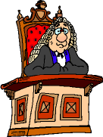
Simplifying Spelling
Name Date
Spelling Rules source: http://www.parkhurstss.eq.edu.au/index.php/about-parkhurst-state-school/curriculum/spelling/
Homonyms
Aug 2018. Kindly contributed by Richard Scott, Warwickshire Adult & Community Learning. Search for Richard on www.skillsworkshop.org
E1-L2 Functional English (writing). For related resources and curriculum links visit the download page for this resource at skillworkshop.
Page 30 of 43
Homographs are words that A calculator is a useful
30 may have more than one object.
meaning or pronunciation. The lawyer said, “I
object!”.
Homophones are words that have
A pair of scissors.
29 the same sound but a different
A pear is a fruit.
meaning and spelling.
Some prefixes ending in a It’s impossible for cows to talk.
28 consonant vary depending on the Cows are incapable of
first letter of the base word. speech.
Prefixes ending in vowels are added
We must all
27 directly to base words. They change the try to recycle.
meaning the meaning of the word.
Prefixes are added to roots to Mr Smith predicts
26 form new words. Roots often have a hot summer.
meanings from other languages. ‘pre’ means ‘before’
and ‘dict’ means ‘say’ (Latin)
Spelling Rules: Quick Guide
Prefixes

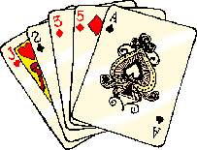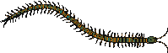
Simplifying Spelling
Name Date
Spelling Rules source: http://www.parkhurstss.eq.edu.au/index.php/about-parkhurst-state-school/curriculum/spelling/
I before E
Aug 2018. Kindly contributed by Richard Scott, Warwickshire Adult & Community Learning. Search for Richard on www.skillsworkshop.org
E1-L2 Functional English (writing). For related resources and curriculum links visit the download page for this resource at skillworkshop.
Page 31 of 43
Some people believe
‘i’ before ‘e’ except after ‘c’ that unicorns exist.
36
(when the sound is “ee”). I received a toy unicorn
in the post.
The knight rode on his horse. It
35 English has many climbed the hill slowly because of
‘silent letters’.
the weight of the armour.

The letter ‘c’ may have a soft
34 or hard sound. When ‘c’ meets centipede (soft c)
an ‘e’, ‘i’ or ‘y’ its sound is soft.
The letter ‘c’ may have a soft
33 or hard sound. When ‘c’ meets cards (hard c)
an ‘a’, ‘o’ or ‘u’ its sound is hard.
The letter ‘g’ may have a soft
32 or hard sound. A soft ‘g’ is usually ‘g’ in ‘gem’ is soft
followed by an ‘i’ or ‘e’.
The letter ‘g’ may have a soft or hard
31 sound. A hard ‘g’ is usually followed ‘g’ in ‘golf’ is hard
by a consonant or an ‘a’, ‘o’ or ‘u’.
Spelling Rules: Quick Guide
Letter sounds


Simplifying Spelling
Name Date
Spelling Rules source: http://www.parkhurstss.eq.edu.au/index.php/about-parkhurst-state-school/curriculum/spelling/
Abbreviations
Capital letters
Aug 2018. Kindly contributed by Richard Scott, Warwickshire Adult & Community Learning. Search for Richard on www.skillsworkshop.org
E1-L2 Functional English (writing). For related resources and curriculum links visit the download page for this resource at skillworkshop.
Page 32 of 43

Missing CAPITAL letters can My best friend is a
42
cause confusion. swede.

CAPITAL letters are also Let’s visit this well
41 used at the beginning of known British
proper adjectives. landmark.
CAPITAL letters are used at
Uluru is a well known
40 the beginning of proper nouns landmark in Australia.
(names and places).
Sometimes when writing, words I need an appointment
39 may be shortened. These are to see Dr Phillips.
known as abbreviations. (Doctor)
Some irregular verbs
He learned his spellings.
38 have more than one He learnt his spellings.
spelling in the past tense.
There are some verbs that do not
I bought (buy) some
37 follow the usual spelling pattern, sweets.
they are called ‘irregular verbs’.
Spelling Rules: Quick Guide
Verbs

Simplifying Spelling
Name Date
Spelling Practice
Aug 2018. Kindly contributed by Richard Scott, Warwickshire Adult & Community Learning. Search for Richard on www.skillsworkshop.org
E1-L2 Functional English (writing). For related resources and curriculum links visit the download page for this resource at skillworkshop.
Page 33 of 43
Practice 1
Practice 2
Practice 3
1

1

1

2

2

2

3

3

3

4

4

4

5

5

5

6

6

6

7

7

7

8

8

8

9

9

9

10

10

10

11

11

11

12

12

12

13

13

13

14

14

14

15

15

15

16

16

16

17

17

17

18

18

18

19

19

19

20

20

20

21

21

21

22

22

22

23

23

23

24

24

24

25

25

25

26

26

26

27

27

27

28

28

28

29

29

29

30

30

30

Simplifying Spelling
Name Date
Spelling Practice
Aug 2018. Kindly contributed by Richard Scott, Warwickshire Adult & Community Learning. Search for Richard on www.skillsworkshop.org
E1-L2 Functional English (writing). For related resources and curriculum links visit the download page for this resource at skillworkshop.
Page 34 of 43
Practice 4
Practice 5
Practice 6
1

1

1

2

2

2

3

3

3

4

4

4

5

5

5

6

6

6

7

7

7

8

8

8

9

9

9

10

10

10

11

11

11

12

12

12

13

13

13

14

14

14

15

15

15

16

16

16

17

17

17

18

18

18

19

19

19

20

20

20

21

21

21

22

22

22

23

23

23

24

24

24

25

25

25

26

26

26

27

27

27

28

28

28

29

29

29

30

30

30

Simplifying Spelling
Name Date
Notes / Questions
Aug 2018. Kindly contributed by Richard Scott, Warwickshire Adult & Community Learning. Search for Richard on www.skillsworkshop.org
E1-L2 Functional English (writing). For related resources and curriculum links visit the download page for this resource at skillworkshop.
Page 35 of 43


Simplifying Spelling
Answers, bibliography and functional skills mapping
Answers
Aug 2018. Kindly contributed by Richard Scott, Warwickshire Adult & Community Learning. Search for Richard on www.skillsworkshop.org
E1-L2 Functional English (writing). For related resources and curriculum links visit the download page for this resource at skillworkshop.
Page 36 of 43

No. of syllables
Syllables
1
acceptable
4
ac-cept-a-ble
2
remember
3
re-mem-ber
3
accommodation
5
ac-com-mo-da-tion
4
occasion
3
oc-ca-sion
5
achieve
2
a-chieve
6
relevant
3
rel-e-vant
7
argument
3
ar-gu-ment
8
beautiful
3
beau-ti-ful
9
separate
2 or 3
sep-arate sep-a-rate
10
because
2
be-cause
11
knowledge
2
knowl-edge
12
believe
2
be-lieve
13
calendar
3
cal-en-dar
14
definite
3
def-i-nite
15
business
2
busi-ness
16
difficult
3
dif-fi-cult
17
embarrass
3
em-bar-rass
18
Wednesday
2
Wednes-day
19
equipment
3
e-quip-ment
20
friend
1
friend
21
communication
5
com-mu-ni-ca-tion
22
necessary
4
nec-es-sar-y
23
queue
1
queue
24
a lot
2 words, 1 syllable in each
a lot
25
receipt
2
re-ceipt
26
restaurant
3
res-tau-rant
27
said
1
said
28
neighbour
2
neigh-bour
29
successful
3
suc-cess-ful
30
write
1
write
Syllables Page 12

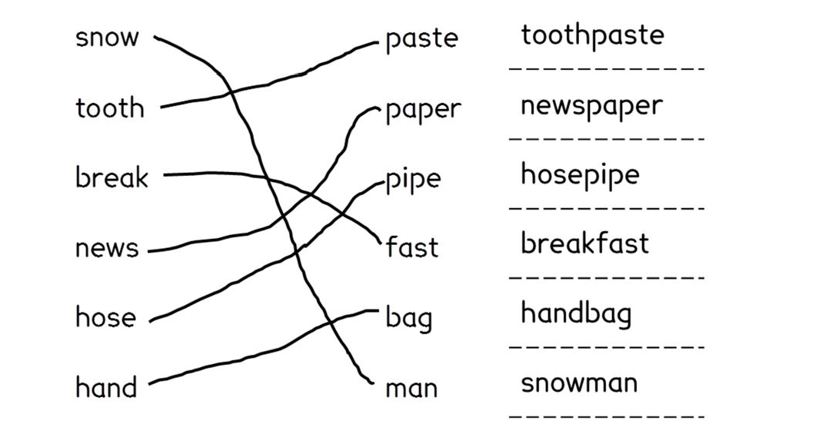
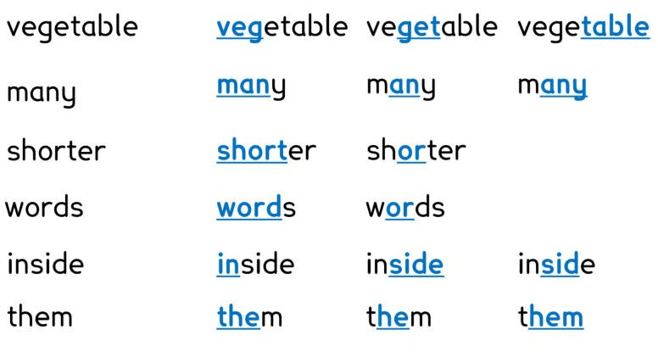
Simplifying Spelling
Answers, bibliography and functional skills mapping
Here are some examples of the words you may have found. You may have
found more.
Aug 2018. Kindly contributed by Richard Scott, Warwickshire Adult & Community Learning. Search for Richard on www.skillsworkshop.org
E1-L2 Functional English (writing). For related resources and curriculum links visit the download page for this resource at skillworkshop.
Page 37 of 43
Words in words Page 13
Compound Words Page 11

Simplifying Spelling
Answers, bibliography and functional skills mapping
Here are some answers for the prefix exercise. You may have found more.
Here are some answers for the suffix exercise. You may have found more.
o
If you lie to me I won’t believe you.
o
o
Add an address to your letter.
The secretary will keep his secret.
o
Since I must rely on you, I am, sincerely yours.
o
You might have to spit when you are in hospital.
Aug 2018. Kindly contributed by Richard Scott, Warwickshire Adult & Community Learning. Search for Richard on www.skillsworkshop.org
E1-L2 Functional English (writing). For related resources and curriculum links visit the download page for this resource at skillworkshop.
Page 38 of 43
Using Sentences - Words in Words Page 23
Base
Suffix
Suffix meaning
Total meaning
walk
ed
past tense
to walk in the past
reply
ing
present tense
to reply in the present
table
s
plural
more than one table
box
es
plural
more than one box
accept
able
fit for
fit to be accepted
use
ful
full of
full of use
arrange
ment
product of
result of arranging
hope
less
without
without hope
friend
ly
like
like a friend
Suffixes Page 16
Prefix meaning
Prefix
Base
Total meaning
before
pre
paid
paid before
after
post
mortem
after death
too much
over
sleep
too much sleep
one
uni
form
one form (one for all)
many
multi
storey
many levels
again
re
play
play again
to take away
de
frost
to take away frost
not
un
fair
not fair
not
dis
agree
to not agree
Prefixes Page 15

Simplifying Spelling
Answers, bibliography and functional skills mapping
Resources that have informed this booklet and further reading
•
•
•
•
•
•
•
http://www.spellingcity.com/richardscott/ http://www.beatingdyslexia.com/spelling-strategies.html http://www.howtospell.co.uk/spellingquiz.php http://www.gamesgames.com/games/spelling http://www.vocabulary.co.il/adult-spelling-programs-how-they-can-help-you/
http://grammar.yourdictionary.com/spelling-and-word-lists/Practice-My-Spelling.html
http://www.oxforddictionaries.com/spelling-challenge
Spelling list sources:
•
http://www.telegraph.co.uk/finance/jobs/11498666/top-ten-spelling-mistakes-job- seekers-employees-cvs-curriculum-vitae.html https://oupeltglobalblog.com/2010/09/30/20-most-commonly-misspelt-words-in- english/
http://www.dailymail.co.uk/news/article-2782743/Embarrassment-fluorescent- accommodate-named-50-words-Britons-difficulty-spelling.html http://businesswriting.com/tests/commonmisspelled.html
http://www.oxforddictionaries.com/words/common-misspellings
•
•
•
•
Spelling rules (pages 26-32) all adapted from:
•
http://www.parkhurstss.eq.edu.au/index.php/about-parkhurst-state-
school/curriculum/spelling/
•
Chambers Adult Learner's Guide to Spelling by Anne Betteridge ISBN: 0550102248 or 9780550102249
Teaching Spelling and Handwriting: A Guide for Undergraduates by D Brook ISBN: 0901437859 or 9780901437853
Spell It Out: The Singular Story of English Spelling by David Crystal
ISBN: 1846685680 or 9781846685682
•
•
Font
The main font used is 'Lexie Readable'. https://www.k-type.com/lexie-readable/
(Regular and bold typefaces are free for personal, educational and charity use).
Aug 2018. Kindly contributed by Richard Scott, Warwickshire Adult & Community Learning. Search for Richard on www.skillsworkshop.org
E1-L2 Functional English (writing). For related resources and curriculum links visit the download page for this resource at skillworkshop.
Page 39 of 43


Simplifying Spelling Functional skills English mapping
Source: DfE (Feb 2018), Subject content functional skills: English Source: DfE (Feb 2018), Subject content functional skills: English https://www.gov.uk/government/publications/functional-skills-subject-content-english
Aug 2018. Kindly contributed by Richard Scott, Warwickshire Adult & Community Learning. Search for Richard on www.skillsworkshop.org
Page 40 of 43
Subject content - FUNCTIONAL SKILLS ENGLISH
→ = not covered in detail in this resource but included to show progression across levels. ✓ indicates content covered in this resource, although this will vary with the student group and how the resource is used by the teacher. (Content at each level subsumes and builds upon the content at lower levels.)
Purpose and learning aims of Functional Skills English
Functional Skills English specifications enable students to develop confidence and fluency in, and a positive attitude towards, English. They should be able to demonstrate their competence by using English in real-world situations as well as demonstrating a sound grasp of basic English knowledge and skills.
They need to provide assessment of students’ underpinning knowledge (i.e. spelling) as well as their ability to apply this in different contexts.
Entry Levels: a qualification to demonstrate the ability at an appropriate level to read, write, speak, listen and communicate in English and provide the basis for further study at Levels 1 and 2. Students should, with some direction and guidance, be able to apply these (Entry Level) English functional skills to informal and some formal contexts, in familiar situations.
Levels 1 and 2: a qualification for work, study and life. Achievement of the qualification demonstrates the ability at an appropriate level to read, write, speak, listen and communicate in English, and apply these skills effectively to a range of purposes in the workplace and other real life situations. Students should be able to communicate with confidence, effectiveness and an increasing level of independence, in a range of formal and informal contexts.
Functional English - Writing
‘Writing’ within Functional Skills English qualifications is defined as the independent construction of written language to communicate in specific contexts. Text can be written on paper or electronically.
Learning aims for writing
E1,2 & 3. Write straightforward texts and documents with clarity and effectiveness, and demonstrate a sound grasp of spelling, punctuation and grammar.
L1-2 (i) Write texts of varying complexity, with accuracy, effectiveness, and correct spelling, punctuation and grammar (ii) Understand the situations when, and audiences for which, planning, drafting and using formal language are important, and when they are less important.
Spelling, punctuation and grammar (SPaG) content descriptors
Entry Level 1
Entry Level 2
Entry Level 3
Level 1
Level 2
E1.15. Spell correctly words designated for Entry Level 1* ✓
E2.14 Form regular plurals ✓ E2.16 Spell correctly words designated for Entry Level 2* ✓
E3.14 Form irregular plurals → E3.17 Spell correctly words designated for Entry Level 3* ✓
L1.21 Spell words used most often in work, study and daily life, including specialist words✓
L2.22 Spell words used in work, study and daily life, including a range of specialist words ✓
Scope of study – learners should write texts that include (content/text types at each level subsume previous levels)
short simple messages and notes

short, straightforward letters, emails and simple narratives

straightforward narratives, instructions, explanations and reports
straightforward narratives, instructions, explanations and reports of varying lengths
straightforward and complex articles, explanations, narratives, and reports of varying lengths
* Refer to the appendix of Subject content functional skills: English (DfE, Feb 2018) or pages 41-43 of this resource.


Simplifying Spelling Functional skills English mapping
Source: DfE (Feb 2018), Subject content functional skills: English Source: DfE (Feb 2018), Subject content functional skills: English https://www.gov.uk/government/publications/functional-skills-subject-content-english
Functional Skills Entry Level 1 – Expectations for spelling
The words have been chosen because they are common words.
Notes for tables on pages 41, 42 & 43: the correspondences between sounds and letters shown in the tables are not exact and should be interpreted flexibly, especially where there are
difference dues to regional accent. The letters underlined in the ‘Letters’ columns correspond to the ‘Sound(s)’ in the adjacent column. These letters may need special attention for spelling. The sounds are shown using the symbols of the International Phonetic Alphabet (IPA) for clarity. It is not necessary for those using the programme of study to understand the symbols, as the letters underlined in the word examples give the sounds represented by the symbols. Students are not expected to understand or use IPA symbols.
Aug 2018. Kindly contributed by Richard Scott, Warwickshire Adult & Community Learning. Search for Richard on www.skillsworkshop.org
Page 41 of 43
Letters
Sound
Letters
Sound(s)
In addition, Entry Level 1 students are expected to spell the words described below. Words in brackets are examples. Words and letters in bold are not examples; they are specific words or spellings that students are expected to both read and spell correctly.
- all common words with one or two
syllables, where the most probable correspondences between sounds and letters are the correct ones (e.g., it, nut, and, stop, rush, thing, himself)
- common two syllable words where
/iː/ at the end is spelled with ‘y’
(e.g., twenty)
- common one or two syllable words with ay and oy, knowing that ay and oy usually correspond to /eɪ/ and /ɔɪ/ at the end of words (e.g., day, runway, boy)
- -ed for the past tense, when the root word remains unchanged (e.g., wanted, opened, jumped)
- the following contractions:
Mr, Mrs
n’t (e.g., didn’t)
’ll (e.g., I’ll)
’re (e.g., we’re)
’s (e.g., it’s)
can, act, look, back, school
/k/
put, push, pull would, could, should, full, look, good
/ʊ/
off
/f/
do, to, into, who, too, you, group, two, room
/u:/
miss, cross, house
/s/
day, say, way, made, make, take, came, same, late, they
/eɪ/
who
/h/
high, right, might, find, mind, child, Friday, by, my, myself, reply, like, time, life, while, I, write
/aɪ/
write, wrote, wrong
/r/
out, about, without, around, now, how, down
/aʊ/
will, well, tell, still, hello
/l/
own, follow, so, no, go, old, over, open, most, only, both, told, hold, don’t, close, show
/əʊ/
get, give
/ɡ/
boy
/ɔɪ/
change, large
/dʒ/
saw, draw, walk, all, call, small, also, water
/ɔ:/
have, give, live, of
/v/
or, for, morning, door, floor, poor, more, before, warm, four, your
/ɔ:/ or /ɔ:r/
is, his, as, has, Wednesday
/z/
her, person, Thursday, Saturday, girl, first, work, word, world, were
/3ː/ or /3ːr/
come, some
/m/
fast, last, past, plant, path, ask, after
/æ/ or /aː/
know, done, one, gone
/n/
are, our
/aː/ or /aːr/
think
/ŋ/
air, where, there, their
/cə/ or/cər/
when, which, what, while, white
/w/
near, here, dear, year
/ɪə/or /ɪər/
see, seem, feel, meet, week, eat, real, be, he, me, we, she, even, every

/iː/

the, between, until, today, together, number, other, after, never, under

/ə/

enjoy
/ɪ/
Tuesday, use, new, few
/juː/
head, any, many, anyone, thank, said, again, says
/e/
little
/ ə l /

come, done, some, other, brother, money, Monday, does
/m/
one, someone, anyone
/ w ʌ /

was, want, what, because
/0/

Simplifying Spelling Functional skills English mapping
Source: DfE (Feb 2018), Subject content functional skills: English Source: DfE (Feb 2018), Subject content functional skills: English https://www.gov.uk/government/publications/functional-skills-subject-content-english
Functional Skills Entry Level 2 – Expectations for spelling
The words have been chosen because they are common words that are not straightforward to spell.
Aug 2018. Kindly contributed by Richard Scott, Warwickshire Adult & Community Learning. Search for Richard on www.skillsworkshop.org
Page 42 of 43
Letters
Sound
Letters
Sound(s)
In addition, Entry Level 2 students are expected to spell the words described below. Words in brackets are examples. Words and letters in bold are not examples; they are specific words or spellings that students are expected to both read and spell.
- words with prefixes where the root word remains
unchanged (e.g., unsure, disappoint, mistake, return, subject, interact, supermarket, autograph)
- words with prefixes where in-, changes to il-, im-, ir-,
before root words that begin with ‘l’, ‘m’, ‘p’, ‘r’ (e.g., illegal, immoral, impossible, irregular)
- words with suffixes where the root word remains
unchanged (e.g., payment, witness, careful, careless, partly)
- words with suffixes where the last ‘e’ in a root word is
dropped before adding a suffix beginning with a vowel (e.g., hoping, liked, safer)
- words with suffixes where a root word ends with a short
vowel sound and a single consonant letter, and the single consonant letter at the end of the root word is doubled before adding a suffix beginning with a vowel or ‘y’ (e.g., chopped, winner, getting, sunny)
- words with suffixes where ‘y’ at the end of the root word
is changed to ‘i’ before adding a suffix beginning with a vowel (e.g., ladies, replied, happier, happiest), but not before ‘–ing’ to avoid ‘ii’ (e.g., replying)
- Words with suffixes ending in ‘-tion’ (e.g., mention,
question, position, action)
- common words with letters corresponding to sounds that are often not pronounced (e.g., February, library, often, every, everything, interest, ordinary)
- the following homophones: there, their, they’re; here, hear; one, won; to, too, two.
letter, better
/t/
woman
/ʊ/
differ, different, difficult,
/f/
move, blue, blew, truly, fruit, group, through
/u:/
address, promise, city, circle, decide, notice, since, sentence, once, answer,

/s/

eight, eighteen, eighty, weigh, weight, daily, great, break, obey, straight

/ei/

sure, sugar, pressure, machine, special
/ʃ/
find, behind, quiet, quite, eye, height,
/ai/
whole
/h/
thought, caught, naughty, cause, always
/ɔ:/
arrive, carry
/r/
forward(s), forty, fourteen, quarter, therefore
/ɔ:/ or
/ɔ:r/
add, address
/d/
perhaps, thirteen, thirty, surprise, year, early, heard, learn, earth
/3ː/ or
/3ːr/
guard, guide
/ɡ/
remember, grammar, calendar, surname, pressure, forward
/ə/ or /3ːr/
age, page, strange,
/dʒ/
half
/aː/ or /æ/
breathe
/ð/
care, bear, bare,
/cə/ or
/cər/
position, possess, potatoes, cause
/z/
our, hour

/aʊə/ or
/aʊr/
imagine
/n/
seven, decide, address, arrive, important, probably, woman, second, difficult
/ə/
mean, people, believe, complete, extreme, everything, everybody
/iː/
idea, material
/iə/
busy, business, minute, build, women, pretty
/i/
six, next
/ks/
friend, anything
/e/
music, beautiful, computer
/juː/
won, son, among, young, touch, double, trouble, country, something, month

/i'/

possible, example, animal

/əl/

watch, knowledge
/0/

Simplifying Spelling Functional skills English mapping
Source: DfE (Feb 2018), Subject content functional skills: English Source: DfE (Feb 2018), Subject content functional skills: English https://www.gov.uk/government/publications/functional-skills-subject-content-english
Functional Skills Entry Level 3 – Expectations for spelling
The words have been chosen because they build on Entry Level 2 by including more of the common words that are often misspelt.
Aug 2018. Kindly contributed by Richard Scott, Warwickshire Adult & Community Learning. Search for Richard on www.skillsworkshop.org
Page 43 of 43
Letters
Sound
Letters
Sound(s)
In addition, Entry Level 3 students are expected to spell the words described below. Words in brackets are examples. Words and letters in bold are not examples; they are specific words or spellings that students are expected to both read and spell.
- common words with the following suffixes or endings
-ion (e.g., competition, discussion)
-ian (e.g., electrician, politician)
-cious, -tious (e.g., suspicious, cautious)
-cial, -tial (e.g., artificial, essential)
-ation, -ant, -ance (e.g., observation, observant, observance)
-ent, -ency (e.g., frequent, frequency)
-able, -ably (e.g., comfortable, comfortably)
-able, -ably, after ‘ge’ and ‘ce’, where ‘e’ is not dropped before adding the suffix (e.g., changeable, noticeably)
-ible’, ‘-ibly (e.g., possible, possibly)
- common words with hyphens to join a prefix to a root word, if the prefix ends in a vowel letter and the root word also begins with one (e.g., re-enter, co-operate)
- common words with letters representing sounds that are often not
pronounced (e.g., desperate, separate, history, category, natural, business, favourite, government, environment)
- the following words that are homophones or near-homophones:

  - who’s, whose • mail, male • guessed, guest
  - accept, except • meat, meet • led, lead
  - berry, bury • missed, mist • past, passed
  - brake, break • peace, piece • aloud, allowed
  - fair, fare • plain, plane • desert, dessert
  - groan, grown • scene, seen • steal, steel
  - heel, he’ll • weather, whether
  - knot, not • farther, father
appear, opposite, apply
/p/
committee, achieve
/i:/
doubt, debt, attach, minute
/t/
average, equip, bargain
/ɪ/
scheme, occasion, according,
/k/
curiosity, qualify, qualification
/0/
picture, actual
/tf/
island
/aɪ/
rough, tough, cough, enough
/f/
though, although,
/eʊ/
listen, fasten, whistle, criticise, receive, purpose, increase, recent, centre, exercise, medicine, experience

/s/

bought, brought, ought, therefore

/ɔ:/

especially, appreciate,

/f/

sugar, popular, particular, regular, centre

/e/ or
/3:r/

guarantee

/g/

competition, correspond, determined, develop, frequently, explanation, dictionary, definite, thorough, borough, describe, experiment, purpose, opposite, suppose, famous, various, certain

/e/

knowledge, college
/d3/
experience
/ɪe/
ease, criticise, position, cause
/z/
excellent
/ks/
measure, treasure, pleasure
/3/
communicate, community, education
/ju:/
committee, bomb, thumb, crumb, climb, condemn, column, autumn
/m/
available

/el/
knot, knee, knife, knowledge
/n/

