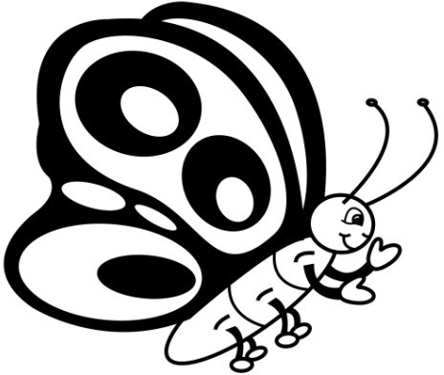
Name
Sight Word Assessment
Lists 1-3
List One
List Two
List Three

Date

get

them

like

one

this

my

would

me

will

yes

big

went

are

come

if

now

long

no

came

ask

very

an

over

your

its

Total

Date

look

is

her

there

some

out

as

be

have

go

we

am

then

little

down

do

can

could

when

did

what

so

see

not

were

Total

Date

the

to

and

he

a

I

you

it

of

in

was

said

his

that

she

for

on

they

but

had

at

him

with

up

all

Total

Name
Sight Word Assessment
Lists 4-6
List Four
List Five
List Six

Date

again

play

who

been

may

stop

off

never

seven

eight

cold

today

fly

myself

round

tell

much

keep

give

work

first

try

new

must

start

Total

Date

away

old

by

their

here

saw

call

after

well

think

ran

let

help

make

going

sleep

brown

yellow

five

six

walk

two

or

before

eat

Total

Date

ride

into

just

blue

red

from

good

any

about

around

want

don’t

how

know

right

put

too

got

take

where

every

pretty

jump

green

four

Total

Name
Sight Word Assessment
Lists 7-9
List Seven
List Eight
List Nine

Date

wash

show

hot

because

far

live

draw

clean

grow

best

upon

these

sing

together

please

thank

wish

many

shall

laugh

Total

Date

warm

ate

full

those

done

use

fast

say

light

pick

hurt

pull

cut

kind

both

sit

which

fall

carry

small

under

read

why

own

found

Total

Date

black

white

ten

does

bring

goes

write

always

drink

once

soon

made

run

gave

open

has

find

only

us

three

our

better

hold

buy

funny

Total

Name
Sight Word Progress Summary
Number of Words
Date


Name
Words I Know Lists 1-3
75

70
65

60
55
50
45
40
35
30
25
20
15
10
5
Date

Name
Words I Know Lists 4-6
75

70
65

60
55
50
45
40
35
30
25
20
15
10
5
Date

Name
Words I Know Lists 1-9
220

210
200

190
180
170
160
150
140
130
120
110
100
90
80
Date


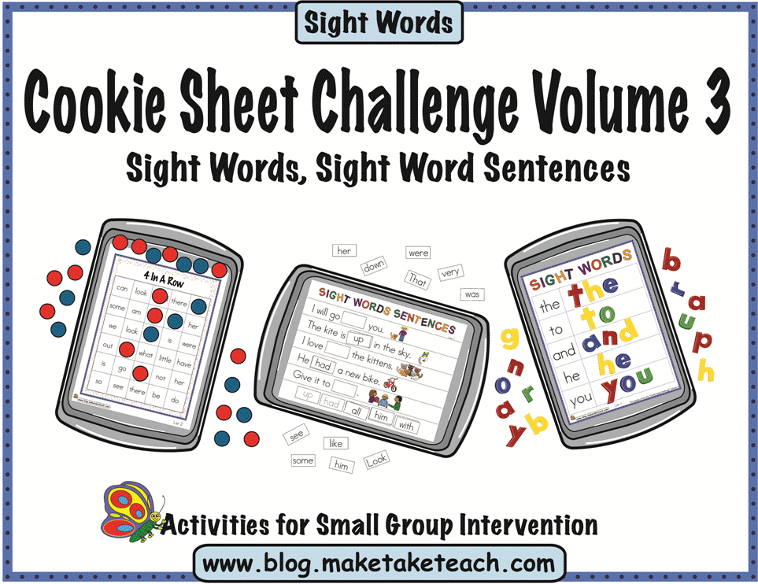
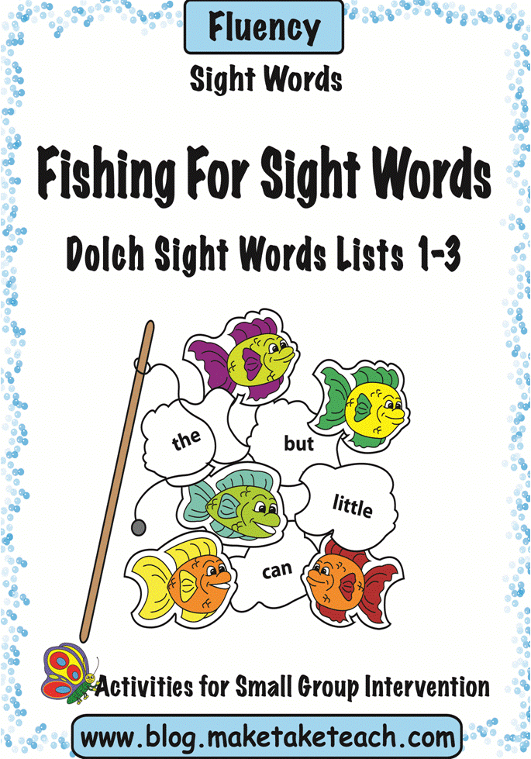
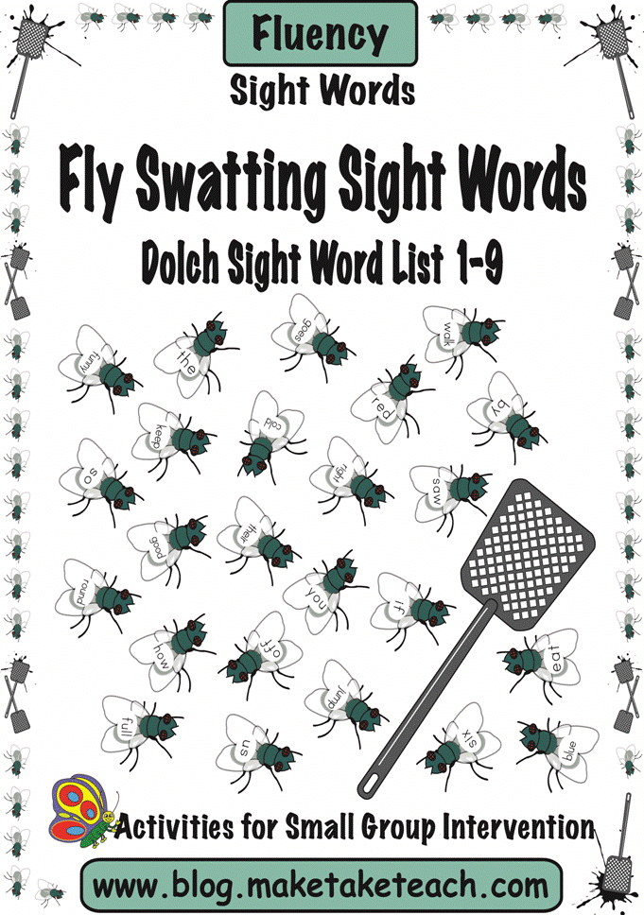
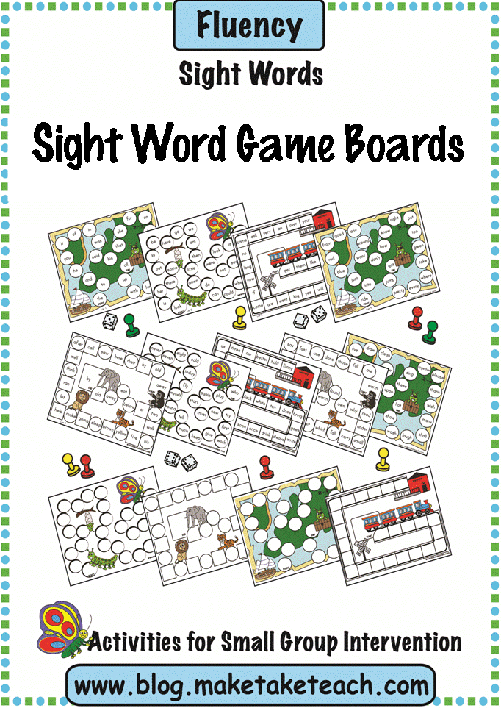
Make, Take & Teach Sight Word Activities
All Make, Take & Teach sight word activities are based on the Dolch 220 Sight
Words.
Consider using these
products during your small group intervention or
within your literacy centers.
Cookie Sheet Challenge Volume 3
Contains 67 templates for use on a cookie sheet. This product targets the following skills: sight word building, sight word identification and using sight words within sentences.
Visit the Make, Take & Teach Teachers Pay Teachers Store or Teacher’s
Notebook for more sight word activities! available too.
Seasonal and Holiday games

