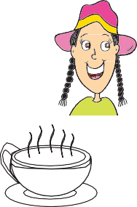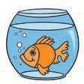
2

Grade 3 Sample English Spelling test

Listen to the sentences.
Write the missing letter or word in the space in each sentence.

Practice questions
P1 There is a word missing. Write the missing word.
I am on the .

- The is shining.

- I am wearing a .

- I drink from a .

- Eat good every day.

- I play on the weekend.

- We eat with our .

- I can the pizza.

- This is a .

- The is happy.

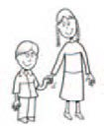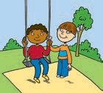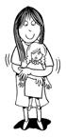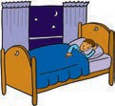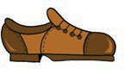
.
3

- My is ten years old.

- The children in the park.

- I my doll.

- I at night.

- The shoe is

- Milk is used to make .

- The story was very .

- The book is on the .

- We went to some clothes.

End of sample English Spelling test.
Stop here.
Wait for your teacher’s instructions


4

Grade 5 Sample English Writing test

Colors
Choose the correct word for each color. The first one has been done for you.

pink
1

2

3

4

5

pink blue brown yellow red green

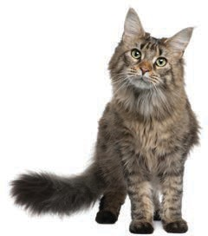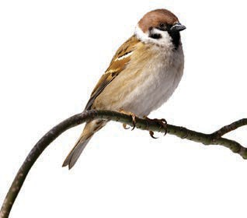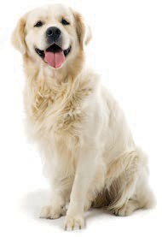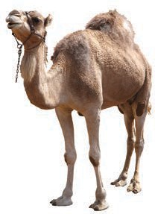
5

Animals
Write the names of the animals.

6

7

8

9

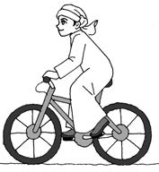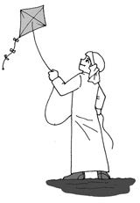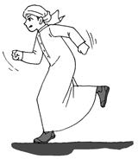
6

What can Khaled do?
Write a sentence for each picture to show what Khaled can do. Use the words under the pictures.
The first one has been done for you.

bicycle Khaled can ride a bicycle.

kite 10

fast 11

songs 12

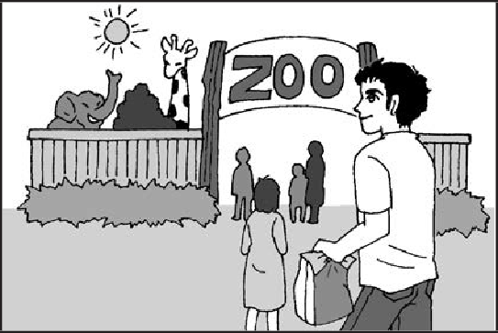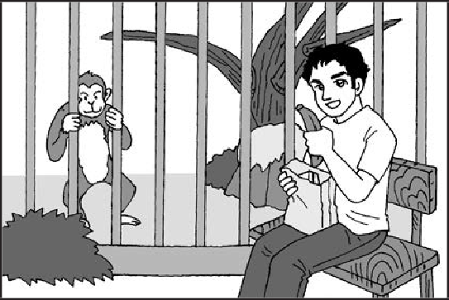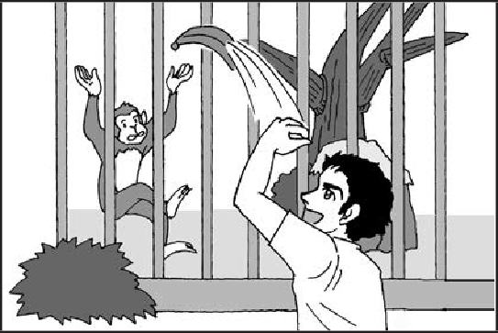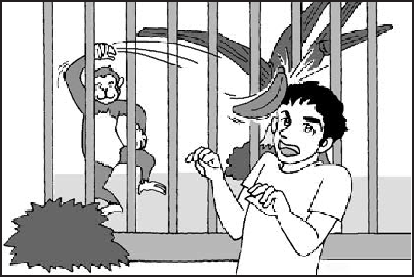
7

At the zoo
Look at the pictures. They tell a story. Tell the story by writing TWO (2)
sentences beside each picture.
The first one has been done for you.

Yesterday Hamad went to the zoo. He took some lunch in a bag.

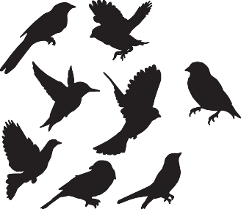
8

Birds
Write about birds.
Write as much as you can. Write inside the box.

End of English Spelling and Writing sample test.

