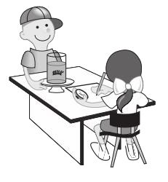
Our Homeschool Schedule

Monday

Tuesday

Wednesday

Thursday

Friday

8am

9am

10am

11am

12pm

1pm

2pm

3pm

