Name:__________________

The Pythagorean Theorem
Find the length of the missing side in the following examples. Round answers to the nearest tenth, if necessary.

1. 2.

6cm c c 5 cm

3 cm 12 cm

5m
3.

7m

4. A ladder is leaning against the side of a 10m house. If the base of the ladder is 3m away from the house, how tall is the ladder? Please draw a diagram and show all work.

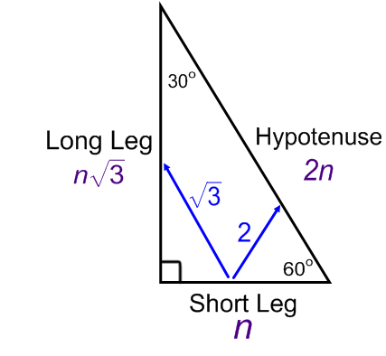
Special Right Triangles: 30º - 60º - 90º
Hypotenuse = 2 * Short Leg
Long Leg = Short Leg *

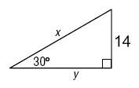
Find the value of x and y in each triangle.
1. 2. 3.

Sketch the figure that is described. Then, find the requested measure.
4. An equilateral triangle has a side length of 10 inches. Find the length of the triangles altitude.

5. The altitude of an equilateral triangle is 18 inches. Find the length of a side.

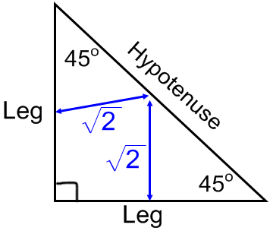
Special Right Triangles: 45º - 45º - 90º
Hypotenuse = Leg *
Leg =

Find the value of x in each triangle.
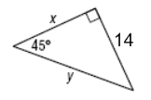
1. 2. 3.

Sketch the figure that is described. Find the requested measure.
4. The perimeter of a square is 48 meters. Find the length of a diagonal.

5. The perimeter of a square is 20 cm. Find the length of a diagonal.

