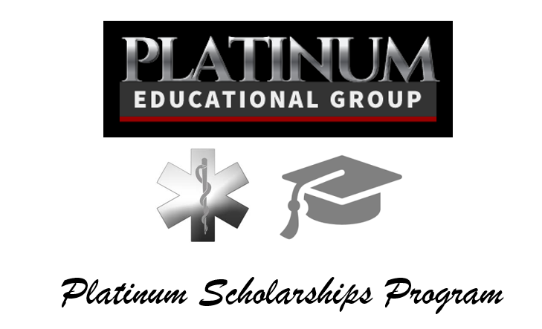

Platinum Educational Groups $1000 EMS Scholarships Program
EMS Scholarships by Platinum Educational Group description:
Our goal is to provide EMS students with assistance in funding their higher education. If you are a student of an accredited EMS program or institution you may be eligible for our scholarships. See eligibility information on the application instructions.
Qualifications:
* Applicant must be attending an accredited EMT/Paramedic Program
* Provide copy of student ID (if your program issues one)
* Provide copy of a State Identification Card
* Letter of Recommendation Form from Program Instructor (form provided)
* Recipients must provide follow-up photo request by Platinum Educational Group
* A brief essay (500 words or less) on what interested you in the Emergency Medical field and what your plans are after graduation
Scholarship Info:
* Two Scholarships awarded annually
* Each Scholarship is for $1000.00
* This is one-time only scholarship per person
* This scholarship will be decided by a panel of community advocates
* Deadline is July 17th, 2015, 5:00PM
* Scholarship money will go directly to awardee’s institution
* Scholarship will be announced between August 4-9, 2015
Platinum Educational Group EMS Scholarships
Application 2015

Please type or print your answers. If application is illegible it will be discarded.
1. | Last Name: |  |  | First Name:
2. | Mailing Address::  Street:  City: State: ZIP:
3. | Daytime Telephone Number: ( )
4. | Email:
5. | I will be enrolled in the following school/program in 2015: _______________________________________________  Proof of acceptance or current student enrollment from the above school is required prior to receipt of funds.
9. | Personal Essay  What interested you in the Emergency Medical Services field and what are your plans after graduation?  Submit your response on separate sheet along with this application [500 words max]
10. | A. The following items must be attached to this application in order for the application to qualify to be  Reviewed by the scholarship committee.  B. Your application will be discarded if these items are not attached to this application. (No exceptions.)  C. Circle “YES” or “NO” to be sure you have attached each item as required.
 | YES | NO | Completed, signed application form [this form]
 | YES | NO | Copy of State ID card
 | YES | NO | Copy of college or program Student ID (If your program issues one)
 | YES | NO | Program Instructor Letter of Recommendation Form (form provided)
 | YES | NO | Personal Essay: What interested you in the Emergency Medical Services field and what are your plans after graduation? [500 words maximum]

STATEMENT OF ACCURACY

I hereby affirm that all the above stated information provided by me is true and correct to the best of my knowledge. I also consent that my picture may be taken and used for any purpose deemed necessary to promote Platinum Educational Group Scholarships program.

Signature of scholarship applicant: ________________________________________________________________

Date: _______________________

All Paperwork Must Be Scanned and Emailed To:
Jeremy M Johnson at jeremy@platinumed.com

REMEMBER

The deadline for this application to be received by Platinum Educational Group is July 17th, 2015, 5:00 p.m.


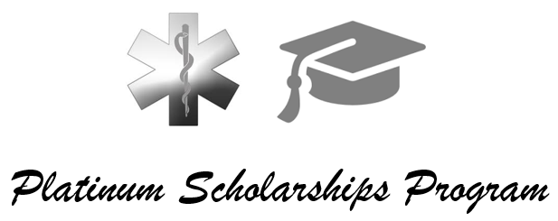

RECOMMENDATION FORM

gENERAL INFORMATION
Instructor/Recommender Name:
Applicant Name:
Program Name and Address:
Phone Number:
Email:

CHECKLIST
How long have you known the applicant?
On average, how large is your classroom size?
Would the applicant rank in the top 20% of the class?
Please describe the applicant’s attitude towards academic work.
Please describe the applicant’s reliability.
Please describe the applicant’s ability to work with others.
What are the applicant’s strengths?
What are the applicant’s weaknesses?
Would you hire this applicant?
Signature of Recommender

