Fiction Stories
*using ordinal words
Name

First

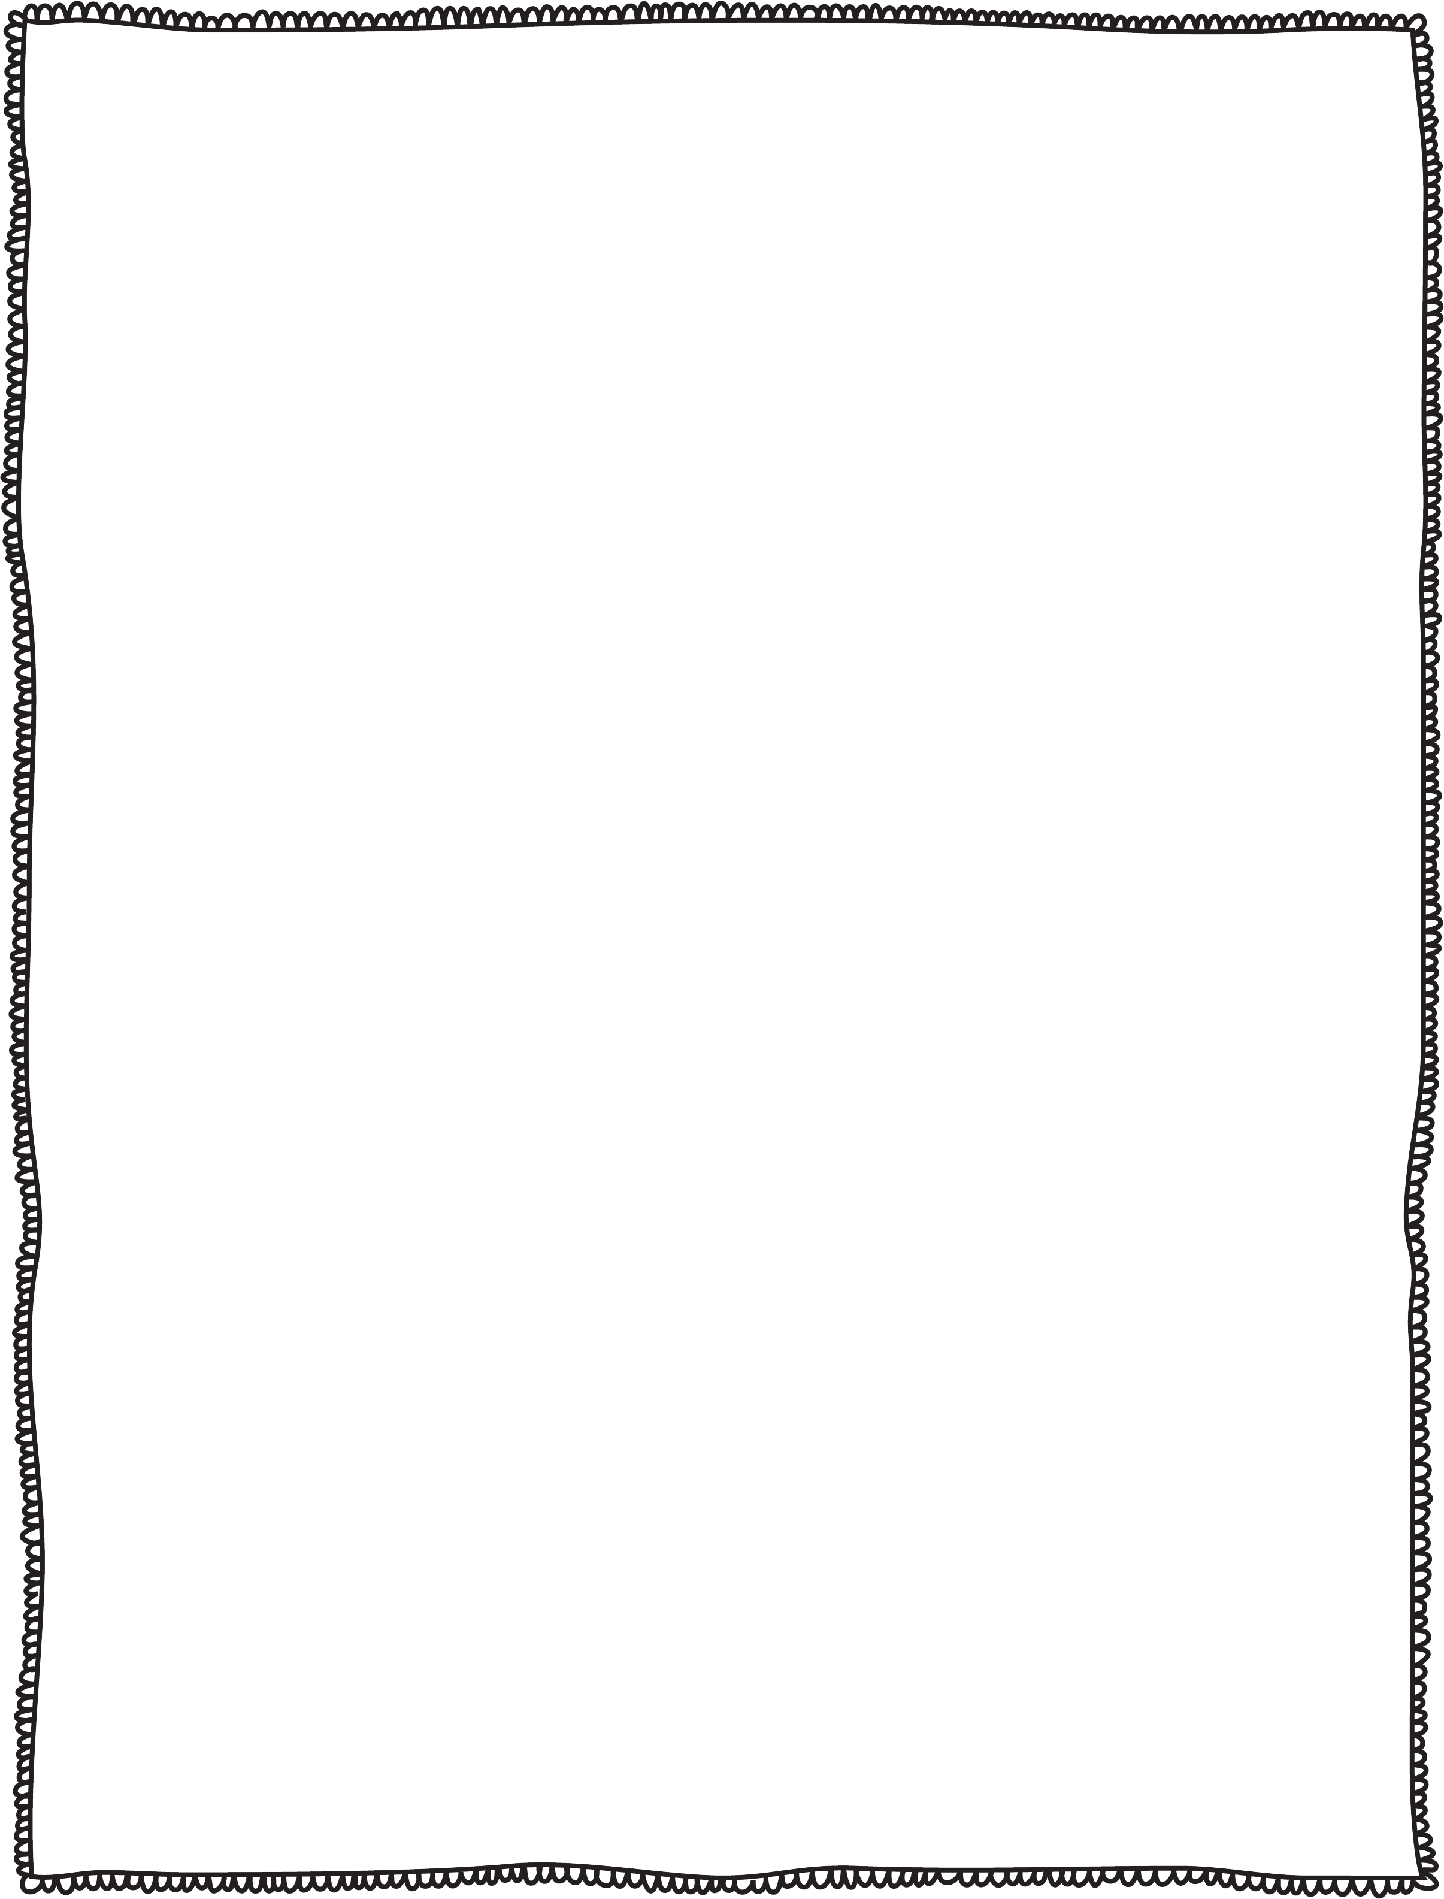
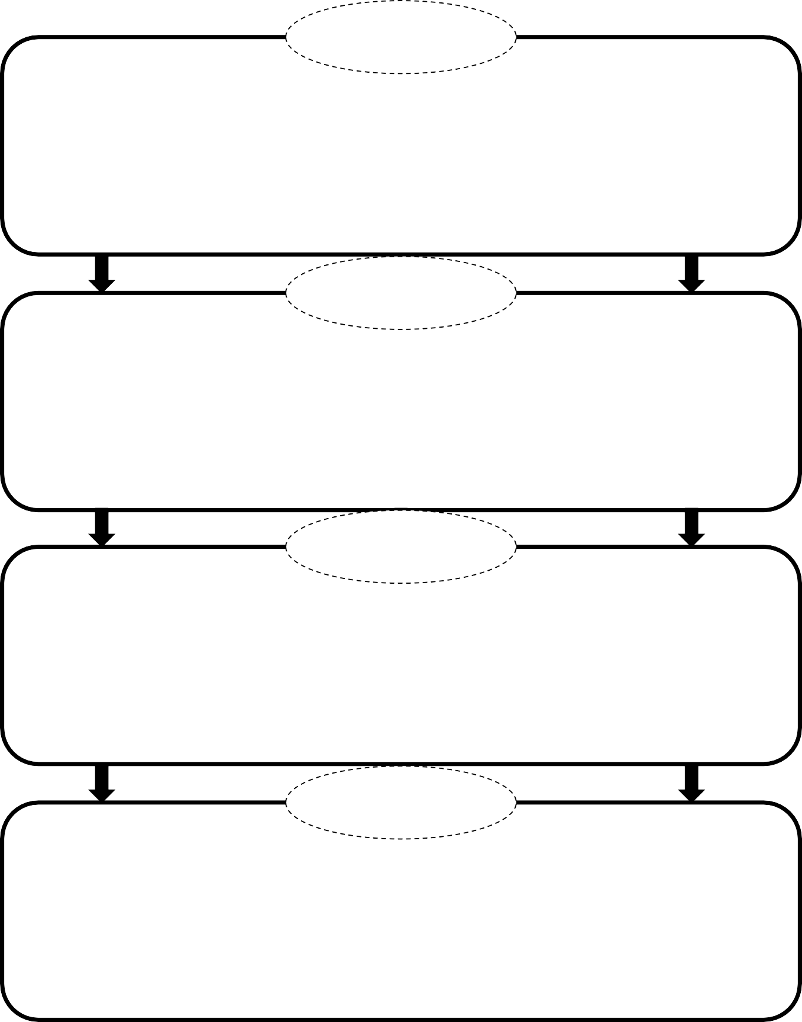

next

then

last

© JD’s Rockin’ Readers

