NOTE CARD
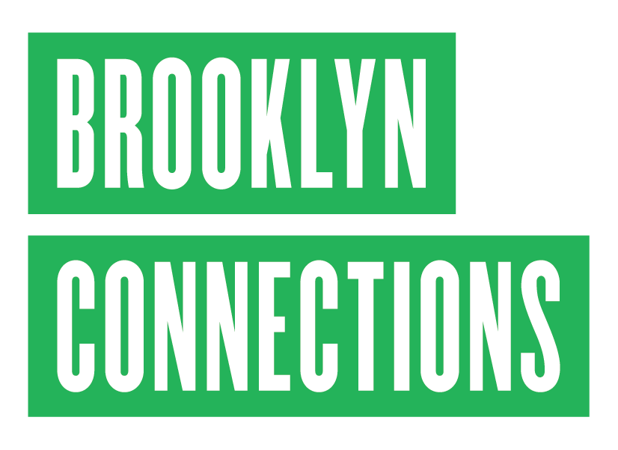

LESSON PLAN

AIM: | Teach students how to use note cards as a means for keeping track of key points and their authors while conducting research.
OBJECTIVE: | Students learn how to identify key points and themes from informational text and notate them on individual note cards with the detail on one side and corresponding citation on the other.
MATERIALS:  (Provided by Brooklyn Connections Educator) | - Note Taking Prezi: http://prezi.com/225puivmczp6/?utm_campaign=share&utm_medium=co py&rc=ex0share  - Note card rings  - Informational Text (Handout)
PROCEDURE: | - Upload the Note Taking Prezi  - Ask students to discuss aloud:  - Why we take notes?  - How do we give credit to sources?  - What makes one detail more important than others?  - Hand out the note card rings  - Explain how to use the note cards  - Write the key detail on the front of the note card  - Write the citation on the back of the note card (how formal the citation depends upon the students’ grade and /or level)  - Students the above points (a. and b.) on one note card to keep as an example  - Distribute the Informational Text (Handout)  - Read the first paragraph of the Informational Text together and ask students to identify the main details from that paragraph  - Agree on the correct main details from the first paragraph  - Students notate these on the front of one of their note cards  - Discuss and agree on the information that makes up the citation on the back of the note card.  - Students notate these on the back of one of their note cards  - Students independently read the Informational Text and annotate the main details  - Split the students into small groups and assign each one paragraph to identify the key details from  - Have groups share the main details they picked out in turn  - Students notate these details on the front of their note cards and add the citations to the back

DIFFERENTIATION  : | - Guide lower level grades and/or students through the informational text by having them take turns reading each paragraph aloud and identifying the corresponding main points from their Informational Text (Handout)  - Use Cornell Notes method for higher level grades and/or students  - Provide several different sources and/or primary sources for higher level grades and/or students
C.C.S.S. ADDRESSED: | 4th Grade  CCSS.ELA-Literacy.RI.4.2 Determine the main idea of a text and explain how it is supported by key details; summarize the text.  CCSS.ELA-Literacy.RI.4.5 Describe the overall structure (e.g., chronology, comparison, cause/effect, problem/solution) of events, ideas, concepts, or information in a text or part of a text.  CCSS.ELA-Literacy.W.4.2 Write informative/explanatory texts to examine a topic and convey ideas and information clearly.  CCSS.ELA-Literacy.W.4.8 Recall relevant information from experiences or gather relevant information from print and digital sources; take notes and categorize information, and provide a list of sources.  5th Grade  CCSS.ELA-Literacy.RI.5.2 Determine two or more main ideas of a text and explain how they are supported by key details; summarize the text.  CCSS.ELA-Literacy.RI.5.5 Compare and contrast the overall structure (e.g., chronology, comparison, cause/effect, problem/solution) of events, ideas, concepts, or information in two or more texts.  CCSS.ELA-Literacy.W.5.2 Write informative/explanatory texts to examine a topic and convey ideas and information clearly.  CCSS.ELA-Literacy.W.5.8 Recall relevant information from experiences or gather relevant information from print and digital sources; summarize or paraphrase information in notes and finished work, and provide a list of sources.  6th Grade  CCSS.ELA-Literacy.RI.6.2 Determine a central idea of a text and how it is conveyed through particular details; provide a summary of the text distinct from personal opinions or judgments.  CCSS.ELA-Literacy.W.6.2 Write informative/explanatory texts to examine a topic and convey ideas, concepts, and information through the selection, organization, and analysis of relevant content.  CCSS.ELA-Literacy.RH.6-8.2 Determine the central ideas or information of a primary or secondary source; provide an accurate summary of the source distinct from prior knowledge or opinions.  CCSS.ELA-Literacy.WHST.6-8.2 Write informative/ explanatory texts, including the narration of historical events, scientific procedures/experiments, or technical processes.

7th Grade
CCSS.ELA-Literacy.RI.7.2 Determine two or more central ideas in a text and analyze their development over the course of the text; provide an objective summary of the text.
CCSS.ELA-Literacy.W.7.2 Write informative/explanatory texts to examine a topic and convey ideas, concepts, and information through the selection, organization, and analysis of relevant content.
CCSS.ELA-Literacy.RH.6-8.2 Determine the central ideas or information of a primary or secondary source; provide an accurate summary of the source distinct from prior knowledge or opinions.
CCSS.ELA-Literacy.WHST.6-8.2 Write informative/ explanatory texts, including the narration of historical events, scientific procedures/ experiments, or technical processes.
8th Grade
CCSS.ELA-Literacy.RI.8.2 Determine a central idea of a text and analyze its development over the course of the text, including its relationship to supporting ideas; provide an objective summary of the text.
CCSS.ELA-Literacy.W.8.2 Write informative/explanatory texts to examine a topic and convey ideas, concepts, and information through the selection, organization, and analysis of relevant content.
CCSS.ELA-Literacy.RH.6-8.2 Determine the central ideas or information of a primary or secondary source; provide an accurate summary of the source distinct from prior knowledge or opinions.
CCSS.ELA-Literacy.WHST.6-8.2 Write informative/ explanatory texts, including the narration of historical events, scientific procedures/ experiments, or technical processes.

9th – 10th Grade
CCSS.ELA-Literacy.RH.9-10.2 Determine the central ideas or information of a primary or secondary source; provide an accurate summary of how key events or ideas develop over the course of the text.

11th – 12th Grade
CCSS.ELA-Literacy.RH.11-12.2 Determine the central ideas or information of a primary or secondary source; provide an accurate summary that makes clear the relationships among the key details and ideas.

CONDUCTING RESEARCH WITH THE NOTE CARD METHOD

Each card covers ONE piece of information.

- The FRONT of the card includes: One fact OR one quote OR one important date, etc.

- The BACK of the card includes Information about WHERE you got the information.

  - Secondary sources - Title, Author, Date, Publisher, City of Publication, Page #
  - Primary sources – Type of Source, Title, Author, Date

Examples:


FRONT
The Brooklyn Bridge opened on
May 24, 1883
BACK
The Encyclopedia of New York City Edited by Kenneth T. Jackson Yale University Press
New Haven, 2010
Page 175


FRONT
A fireworks display was held to celebrate the opening of the Brooklyn Bridge.
BACK
Drawing
“The Great East River Bridge – Fireworks and Illumination” Harper’s Weekly Newspaper June 2, 1883

STEPS TO USING NOTE CARDS


Use the passage below to practice. Try to identify the main idea of the paragraph in ONE note (it does not need to be a complete sentence).
- Identify a key detail or note.

- Record observation on the front of the card.

- Cite the AUTHOR(S) and TITLE on the back of the notecard.

Using the boxes at the bottom of the page,
record your note and cite it.

Canarsie

Originally a part of Flatlands, Canarsie was the named for the native people who occupied it at the time of European settlement. It was a quiet area for fishing and farming for much of the 18th century. Germans settled the area in the 1870s, followed by Dutch, Scotch, and the Irish. By the 1920s, Italians and Jewish
people began to move into the area—many of whom, made their living as fishermen or oystermen.

CITATION: Jackson, Kenneth T. “Canarsie.” The Encyclopedia of New York City. 2nd ed. 2010. Print.

Front Back



Jamaica Bay
Jamaica Bay is a shallow tidal wetland of about 20 square miles between Brooklyn and Queens. It forms a large part of the Gateway National Recreation Area. Within it are dozens of islands, of which only the largest, Broad Channel, is inhabited. On the northern half of this island is the Jamaica Bay Wildlife Refuge, which has two freshwater ponds and a remarkable number of shorebirds and is the largest urban refuge in the United States built on landfill wholly within the boundaries of a city.
Before the arrival of the Dutch, the bay was a favorite fishing and hunting ground for the Canarsee and Rockaway Indians. It was sparsely settled until 1880, when the New York, Woodhaven, and Rockaway Railroad built a wooden trestle 5 miles long across the bay to connect the Rockaways to the rest of Queens.
The bay became increasingly polluted by expanding industry along the shores and by two sewers, one in Canarsie and one in Jamaica. In 1916 fishing and swimming were banned by the Board of Health, and all the summer resort hotels closed.
The opening in the mid-1920s of the Cross Bay Boulevard made Broad Channel accessible to automobiles and further development. After a fire in 1950 destroyed the wooden railroad trestle, the Metropolitan Transit Authority acquired the property and rebuilt the line, connecting it to the subway system in 1953, maintaining a station at Broad Channel.
In the 1980s efforts to clean up the waters achieved considerable success. The Jamaica Bay Wildlife Refuge has become a popular destination for bird lovers and those seeking “refuge” from the busy city.

CITATION: Wolfe, Gerard R. "Jamaica Bay." The Encyclopedia of New York City. New Haven: Yake University Press, 2010. Print.

GLOSSARY

shorebirds – birds that spend most of their time near the shore

sparsely – few and scattered

tidal wetland – tidal wetlands are the areas where the land meets the sea. These areas are periodically flooded by seawater during high or spring tides or, are affected by the cyclic changes in water levels caused by the tidal cycle.

trestle – a framework consisting of a horizontal beam supported by two pairs of sloping legs, like in a bridge

