Co-Author: The Go-Giver Series / Author: Endless Referrals, Adversaries into Allies
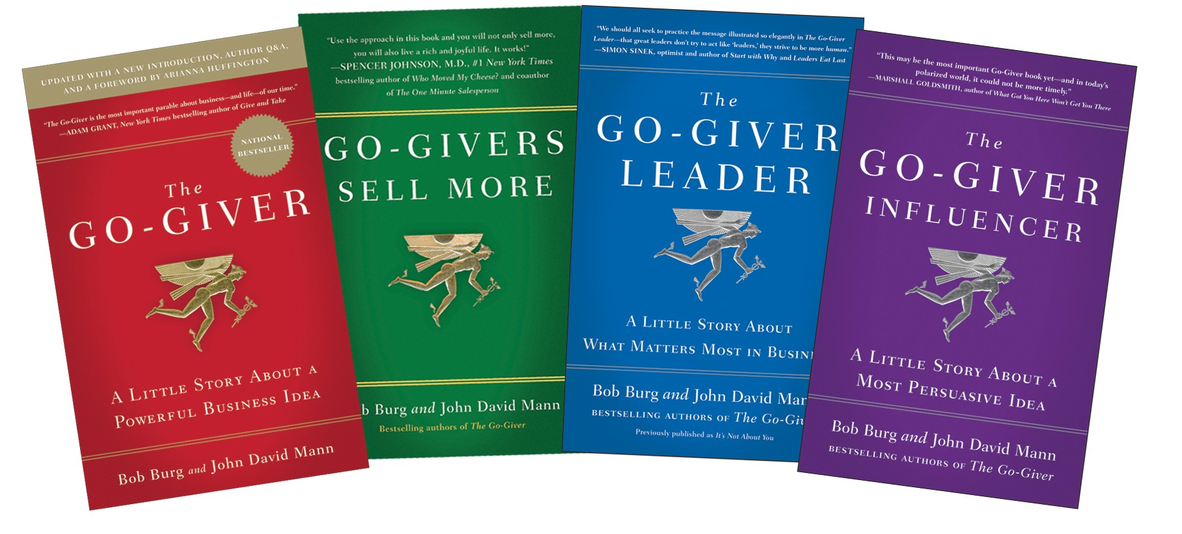

Bob Burg
National Bestselling Author & Critically Acclaimed Speaker


AND


BESTSELLER

